LEARNER GUIDE

Conduct Sales And Support Services

Unit Standard 259886
Level 4 Credits 16

TABLE OF CONTENTS
TABLE OF CONTENTS i
PERSONAL INFORMATION 1
INTRODUCTION 2
Structure 3
Programme methodology 3
What Learning Material you should have 4
Different types of activities you can expect 5
Assessments 6
Learner Support 7
Learner Administration 7
Learner Expectations 8
UNIT STANDARD 259886 9
SECTION 1: DESCRIBE THE INDUSTRY 14
Sectors Of Business: The Distribution Chain SO5 AC1 14
Sectors of Business 14
Summary 14
Manufacturers 15
Wholesalers 15
Retailers 15
Services 15
Sub-sectors 19
Divisions of industry 20
Industry Specific Information SO5 AC2 21
Retail Legislation SO5 AC3-4 22
Consumer Protection Act 22
Change owner or titleholder particulars for a vehicle 25
Installment Sale 26
Lease 27
Explanations 27
SECTION 2: SALES PROCEDURES AND BUYING SIGNALS 30
Buying Psychology (EEK) 30
Sales Philosophy (EEK) 32
Features, Advantages, Benefits (EEK) 32
Product Knowledge 32
Product Features, Advantages and Benefits 33
Product features 35
Benefits 37
Advantages 40
Selling benefits and features 40
Link Features, Advantages and benefits 44
Sales Procedure SO1 AC1-3 and (EEK) 48
The seven steps of the sale 48
Four steps 56
15 Step Car Sales Technique 58
Buying Signals 60
SECTION 3: HANDLE OBJECTIONS 65
Introduction 65
Objection-Handling Process SO4 AC3 66
Techniques for handling objections 66
Objection-handling techniques and methods 66
Boomerang method 67
Conditional Close 67
Curiosity 67
Fallback 68
Fear, Uncertainty and Doubt (FUD) 68
LAARC 69
Objection Writing 69
Company Policies And Procedures AC1-2 (EEK Sales Presentations) 70
Successful sales presentations 70
Sales presentation methods 70
What is the best presentation method? 79
Group Presentations 80
First select the presentation method, then the approach 80
The Parallel Dimensions of Selling 81
Tips for sales presentations 82
SECTION 4: CLOSE THE DEAL 84
Obtain Customer’s Commitment To Purchase SO6 AC1 84
The Columbo Close (Just one more thing) 85
Assumptive Close 85
Puppy dog Close 86
Hard close 86
Take away close 87
Relationship Close SO6 AC2 87
Distribute Documents SO6 AC3 88
SECTION 5: NEGOTIATE 89
Introduction: Negotiating Styles And Tips 89
The Phases of Negotiation 90
How to negotiate a sale 90
Four square system 91
Sales Negotiations SO2 AC1-3 92
SECTION 6: QUOTES 93
Conditions Of Sale SO3 AC1 93
Commitment From All Departments SO3 AC2 94
Present The Quotation SO3 AC3 94
REFERENCES 95
FORMATIVE ASSESSMENTS WORKBOOK 96
Formative assessments SO5 96
Formative assessments SO1 111
Formative assessments SO4 124
Formative assessments SO6 134
Formative assessments SO2 137
Formative assessments SO3 138

PERSONAL INFORMATION

NAME
CONTACT ADDRESS
Code
Telephone (H)
Telephone (W)
Cellular
Learner Number
Identity Number
EMPLOYER
EMPLOYER CONTACT ADDRESS
Code
Supervisor Name
Supervisor Contact Address
Code
Telephone (H)
Telephone (W)
Cellular

INTRODUCTION

Welcome to the learning programme

Follow along in the guide as the training practitioner takes you through the material. Make notes and sketches that will help you to understand and remember what you have learnt. Take notes and share information with your colleagues. Important and relevant information and skills are transferred by sharing!



This learning programme is divided into sections. Each section is preceded by a description of the required outcomes and assessment criteria as contained in the unit standards specified by the South African Qualifications Authority. These descriptions will define what you have to know and be able to do in order to be awarded the credits attached to this learning programme. These credits are regarded as building blocks towards achieving a National Qualification upon successful assessment and can never be taken away from you!

Structure

Programme methodology
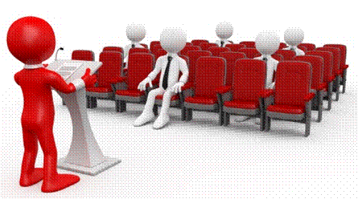

The programme methodology includes facilitator presentations, readings, individual activities, group discussions and skill application exercises.
Know what you want to get out of the programme from the beginning and start applying your new skills immediately. Participate as much as possible so that the learning will be interactive and stimulating.
The following principles were applied in designing the course:
- Because the course is designed to maximise interactive learning, you are encouraged and required to participate fully during the group exercises
- As a learner you will be presented with numerous problems and will be required to fully apply your mind to finding solutions to problems before being presented with the course presenter’s solutions to the problems
- Through participation and interaction the learners can learn as much from each other as they do from the course presenter
- Although learners attending the course may have varied degrees of experience in the subject matter, the course is designed to ensure that all delegates complete the course with the same level of understanding
- Because reflection forms an important component of adult learning, some learning resources will be followed by a self-assessment which is designed so that the learner will reflect on the material just completed.
This approach to course construction will ensure that learners first apply their minds to finding solutions to problems before the answers are provided, which will then maximise the learning process which is further strengthened by reflecting on the material covered by means of the self-assessments.

Different role players in delivery process
- Learner
- Facilitator
- Assessor
- Moderator

What Learning Material you should have
This learning material has also been designed to provide the learner with a comprehensive reference guide. It is important that you take responsibility for your own learning process; this includes taking care of your learner material. You should at all times have the following material with you:
  Learner Guide | This learner guide is your valuable possession:  This is your textbook and reference material, which provides you with all the information you will require to meet the exit level outcomes. During contact sessions, your facilitator will use this guide and will facilitate the learning process. During contact sessions a variety of activities will assist you to gain knowledge and skills.  Follow along in the guide as the training practitioner takes you through the material. Make notes and sketches that will help you to understand and remember what you have learnt. Take and share information with your colleagues. Important and relevant information and skills are transferred by sharing!  This learning programme is divided into sections. Each section is preceded by a description of the required outcomes and assessment criteria as contained in the unit standards specified by the South African Qualifications Authority. These descriptions will define what you have to know and be able to do in order to be awarded the credits attached to this learning programme. These credits are regarded as building blocks towards achieving a National Qualification upon successful assessment and can never be taken away from you!
  Formative Assessment Workbook | The Formative Assessment Workbook supports the Learner Guide and assists you in applying what you have learnt.  The formative assessment workbook contains classroom activities that you have to complete in the classroom, during contact sessions either in groups or individually.  You are required to complete all activities in the Formative Assessment Workbook. The facilitator will assist, lead and coach you through the process. These activities ensure that you understand the content of the material and that you get an opportunity to test your understanding.

Different types of activities you can expect
To accommodate your learning preferences, a variety of different types of activities are included in the formative and summative assessments. They will assist you to achieve the outcomes (correct results) and should guide you through the learning process, making learning a positive and pleasant experience.

The table below provides you with more information related to the types of activities.
Types of Activities | Description | Purpose
Knowledge Activities   | You are required to complete these activities on your own. | These activities normally test your understanding and ability to apply the information.
Skills Application Activities   | You need to complete these activities in the workplace | These activities require you to apply the knowledge and skills gained in the workplace
  Natural Occurring Evidence | You need to collect information and samples of documents from the workplace. | These activities ensure you get the opportunity to learn from experts in the industry.  Collecting examples demonstrates how to implement knowledge and skills in a practical way

Assessments
The only way to establish whether a learner is competent and has accomplished the specific outcomes is through the assessment process. Assessment involves collecting and interpreting evidence about the learners’ ability to perform a task.
To qualify and receive credits towards your qualification, a registered Assessor will conduct an evaluation and assessment of your portfolio of evidence and competency.
This programme has been aligned to registered unit standards. You will be assessed against the outcomes as stipulated in the unit standard by completing assessments and by compiling a portfolio of evidence that provides proof of your ability to apply the learning to your work situation.


How will Assessments commence?

Formative Assessments
The assessment process is easy to follow. You will be guided by the Facilitator. Your responsibility is to complete all the activities in the Formative Assessment Workbook and submit it to your facilitator.

Summative Assessments
You will be required to complete a series of summative assessments. The Summative Assessment Guide will assist you in identifying the evidence required for final assessment purposes. You will be required to complete these activities on your own time, using real life projects in your workplace or business environment in preparing evidence for your Portfolio of Evidence. Your Facilitator will provide more details in this regard.
To qualify and receive credits towards your qualification, a registered Assessor will conduct an evaluation and assessment of your portfolio of evidence and competency.

Learner Support
The responsibility of learning rests with you, so be proactive and ask questions and seek assistance and help from your facilitator, if required.


Please remember that this Skills Programme is based on outcomes based education principles which implies the following:
- You are responsible for your own learning – make sure you manage your study, research and workplace time effectively.
- Learning activities are learner driven – make sure you use the Learner Guide and Formative Assessment Workbook in the manner intended, and are familiar with the workplace requirements.
- The Facilitator is there to reasonably assist you during contact, practical and workplace time for this programme – make sure that you have his/her contact details.
- You are responsible for the safekeeping of your completed Formative Assessment Workbook and Workplace Guide
- If you need assistance please contact your facilitator who will gladly assist you.
- If you have any special needs please inform the facilitator

Learner Administration


Attendance Register
You are required to sign the Attendance Register every day you attend training sessions facilitated by a facilitator.

Programme Evaluation Form
On completion you will be supplied with a “Learning programme Evaluation Form”. You are required to evaluate your experience in attending the programme.
Please complete the form at the end of the programme, as this will assist us in improving our service and programme material. Your assistance is highly appreciated.

Learner Expectations
Please prepare the following information. You will then be asked to introduce yourself to the instructor as well as your fellow learners


Your name:
The organisation you represent:
Your position in organisation:
What do you hope to achieve by attending this course / what are your course expectations?

UNIT STANDARD 259886

AFRICAN QUALIFICATIONS AUTHORITY

REGISTERED UNIT STANDARD:

Conduct sales and support services

SAQA US ID | UNIT STANDARD TITLE
259886 | Conduct sales and support services
ORIGINATOR
SGB Retail and Wholesale
QUALITY ASSURING BODY
-
FIELD |  |  | SUBFIELD
Field 11 - Services |  |  | Wholesale and Retail
ABET BAND | UNIT STANDARD TYPE | PRE-2009 NQF LEVEL | NQF LEVEL | CREDITS
Undefined | Regular | Level 4 | NQF Level 04 | 16
REGISTRATION STATUS |  | REGISTRATION START DATE | REGISTRATION END DATE | SAQA DECISION NUMBER
Reregistered |  | 2015-07-01 | 2018-06-30 | SAQA 10105/14
LAST DATE FOR ENROLMENT |  | LAST DATE FOR ACHIEVEMENT
2019-06-30 |  | 2022-06-30

In all of the tables in this document, both the pre-2009 NQF Level and the NQF Level is shown. In the text (purpose statements, qualification rules, etc), any references to NQF Levels are to the pre-2009 levels unless specifically stated otherwise.

This unit standard replaces:

US ID | Unit Standard Title | Pre-2009 NQF Level | NQF Level | Credits | Replacement Status
9848 | Conduct sales in motor sales and support services | Level 4 | NQF Level 04 | 16 | Complete

PURPOSE OF THE UNIT STANDARD

A Learner is capable of conducting sales in a specific industry by presenting the products and services to the customer in such a way that is conducive to a successful sale. A Learner is capable of acting in such a manner to enhance the image of the specific retail industry.
On achievement of this unit standard, the learner will be able to:
• Identify early buying signals and act thereupon.
• Negotiate and/or agree to the terms and conditions of the sale.
• Prepare quotations according to organisational standard policies and procedures.
• Handle and deal with customer objections and concerns.
• Describe the current state of a specific industry.
• Close the deal and obtain customer commitment.

LEARNING ASSUMED TO BE IN PLACE AND RECOGNITION OF PRIOR LEARNING

It is assumed that a learner will be competent in:
• Communication at NQF Level 3.
• Mathematical Literacy at NQF Level 3.

UNIT STANDARD RANGE

N/A

Specific Outcomes and Assessment Criteria:

SPECIFIC OUTCOME 1

Identify early buying signals and act thereupon.

ASSESSMENT CRITERIA

ASSESSMENT CRITERION 1

The characteristics of early buying signals are described, as is applicable to a specific industry.

ASSESSMENT CRITERION 2

The reaction to early buying signals is demonstrated according to organisational procedures in a structured scenario.

ASSESSMENT CRITERION 3

The standard company sales procedures are explained in terms of obtaining a prospective buyer's commitment.

SPECIFIC OUTCOME 2

Negotiate and/or agree to the terms and conditions of the sale.

ASSESSMENT CRITERIA

ASSESSMENT CRITERION 1

Items requiring agreement are identified to the satisfaction of the customer and organisation.

ASSESSMENT CRITERION 2

An agreement on the supply of the product/service is concluded that meets the requirement of all parties.

ASSESSMENT CRITERION RANGE

All parties may include but is not limited to the client; external suppliers and the retailer.

ASSESSMENT CRITERION 3

Agreements are formalised and documented according to organisational requirements.

ASSESSMENT CRITERION RANGE

Organisational requirements may include but are not limited to legal prescripts.

SPECIFIC OUTCOME 3

Prepare quotations according to organisational standard policies and procedures.

OUTCOME RANGE

The above specific outcome must take cognisance of any impacting legislation.

ASSESSMENT CRITERIA

ASSESSMENT CRITERION 1

Conditions of the sale are defined in terms of company procedures and legislative framework.

ASSESSMENT CRITERION 2

The commitment of, internal and external departments are formalized to meet the requirements of the quotation.

ASSESSMENT CRITERION 3

Quotation is presented according to organisational and legislative and legal requirements.

SPECIFIC OUTCOME 4

Handle and deal with customer objections and concerns.

ASSESSMENT CRITERIA

ASSESSMENT CRITERION 1

The method of clarifying and addressing concerns and objections of customers are described in terms of organisational policies.

ASSESSMENT CRITERION 2

A proposal to address customer objections and concerns is formulated in terms of company policies and procedures.

ASSESSMENT CRITERION 3

The procedures to deal with unresolved objections and concerns are described in terms of company policy.

SPECIFIC OUTCOME 5

Describe the current state of a specific industry.

ASSESSMENT CRITERIA

ASSESSMENT CRITERION 1

Divisions of a specific industry are described with reference to the role and contribution of each division to the industry.

ASSESSMENT CRITERION 2

Industry specific information is analysed to determine trends and availability.

ASSESSMENT CRITERION 3

The purpose of specific Legislation relating to an industry division is described in terms of the objectives.

ASSESSMENT CRITERION 4

The consequences of non-compliance to industry specific legislation are described in terms of the legislation.

SPECIFIC OUTCOME 6

Close the deal and obtain customer commitment.

ASSESSMENT CRITERIA

ASSESSMENT CRITERION 1

The Customer's commitment to purchase is formalised and a cause of action agreed according to organisation policies and procedures.

ASSESSMENT CRITERION 2

The ability to secure a future relationship with the customer is demonstrated in terms of company policies and procedures.

ASSESSMENT CRITERION 3

The process to distribute the different documents is explained according to company procedures.

UNIT STANDARD ACCREDITATION AND MODERATION OPTIONS

• An individual wishing to be assessed against the unit standard (including through RPL) may apply to an assessment agency, assessor or provider institution accredited by the relevant Education and Training Quality Assurance body (ETQA), or one with an appropriate memorandum of understanding (MOU) with the relevant ETQA.
• Anyone assessing a learner against this unit standard must be registered as an assessor with the relevant ETQA, or one with an appropriate MOU with the relevant ETQA.
• Any institution offering learning that will enable achievement of this unit standard, or assessing this unit standard, must be accredited as a provider with the relevant ETQA, or one with an appropriate MOU with the relevant ETQA.
• Moderation of assessment will be conducted by the relevant ETQA, or one with an appropriate MOU with the relevant ETQA.
• Moderation should include both internal and external moderation where applicable.

UNIT STANDARD ESSENTIAL EMBEDDED KNOWLEDGE

• Presentation skills related to the retail industry.
• Product knowledge, FABs (Features and benefits), communication skills.
• Selling skills (buying psychology).
• Add on products and services.
• Negotiation skills related to product, price, terms and conditions.
• Organisational policies and procedures.
• Legislative requirements.
• Organisational policies/Trading concessions.
• Market intelligence.
• Basic financial and business skills.
• Conflict handling skills.
• Identification of buying signals.
• Features Advantages Benefits.

UNIT STANDARD DEVELOPMENTAL OUTCOME

N/A

UNIT STANDARD LINKAGES

N/A

Critical Cross-field Outcomes (CCFO):

UNIT STANDARD CCFO IDENTIFYING

Identify and solve problems in a critical and creative way when presenting products and services to the customer in such a way that is conducive to a successful sale.

UNIT STANDARD CCFO WORKING

Work effectively with others as a member of a sales team in the automotive industry.

UNIT STANDARD CCFO ORGANISING

Organise and manage oneself and one's personal activities responsibly and effectively.

UNIT STANDARD CCFO COLLECTING

Collect, analyse, organise and critically evaluate information relevant to conducting sales in the automotive vehicles.

UNIT STANDARD CCFO DEMONSTRATING

• Understand and apply a range of office management-related techniques, procedures and experimental approaches required in the different specific programmes leading up to this qualification.
• Understand the world as a set of related systems by recognising that conducting sales in the automotive industry do not exist in isolation.

UNIT STANDARD ASSESSOR CRITERIA

N/A

UNIT STANDARD NOTES

This unit standard replaces unit standard 9848, "Conduct sales in motor sales and support services", Level 4, 16 credits.

QUALIFICATIONS UTILISING THIS UNIT STANDARD:

 | ID | QUALIFICATION TITLE | PRE-2009 NQF LEVEL | NQF LEVEL | STATUS | END DATE | QUALITY ASSURING BODY
Core | 64289 | Further Education and Training Certificate: Automotive Sales and Support Services | Level 4 | NQF Level 04 | Reregistered | 2018-06-30 | MERSETA

SECTION 1: DESCRIBE THE INDUSTRY

Specific outcome 5
Describe the current state of a specific industry

Assessment criteria
- Divisions of a specific industry are described with reference to the role and contribution of each division to the industry
- Industry specific information is analysed to determine trends and availability
- The purpose of specific Legislation relating to an industry division is described in terms of the objectives
- The consequences of non-compliance to industry specific legislation are described in terms of the legislation

Essential Embedded Knowledge
- Legislative requirements
- Market intelligence
- Basic financial and business skills

CCFO
Working: Work effectively with others as a member of a sales team in the automotive industry

Sectors Of Business: The Distribution Chain SO5 AC1

Sectors of Business
We can classify businesses according to their activities:
- Primary sector: This sector is involved in exploiting natural resources in their raw and unprocessed form. This would be the dairy farmer and the mining company.
- Secondary sector: This sector is involved in processing and converting these exploited natural resources into a final product. This would be Dairy Belle, who buys the milk from the farmer, processes and packages it and delivers it to the retailer. We classify them as wholesalers.
- Tertiary sector: This sector is responsible for conveying the final products from the manufacturer to the consumer. This would be the supermarket, the spaza shop, wherever you buy your milk. We classify them as retail trade.

Summary
Let’s summarise all the above:
- BMW is classified as a manufacturer and they form part of the secondary business sector, since they use raw materials such as steel, cloth and leather, and convert it into a finished product. This product is then sent to their agents for selling purposes.
- These agents are part of the tertiary business sector and they form part of the retail industry.
- BMW will get the “raw” steel from ISCOR, which is part of the primary sector, as they exploit natural resources in their raw and unprocessed form.
A couple of explanations to help you distinguish between types of businesses:

Manufacturers
A manufacturer processes raw materials into finished products, ready for resale or distribution to wholesalers or direct to retailers. Examples include:
- Furniture manufacturers
- Clothing manufacturers
- Car manufacturers

Wholesalers
Wholesalers are the intermediary companies that act between manufacturers and retailers or industrial users by assembling, storing and distributing products. Examples are Makro, Trade Centre. When you buy from a wholesaler, you have to buy in bulk. You are not usually able to buy only one or two items of a product. These days you can buy one or two items of a product from wholesalers such as Makro, but the prices are usually not that much cheaper than you would find at the retailer.

Retailers
The retail industry is a sector of the economy that is comprised of individuals and companies engaged in the selling of finished products to end user consumers
Retailers usually break bulk products into saleable portions. Examples are:
- supermarkets,
- butchers,
- cell phone shops,
- spazas,
- convenience stores

Services
A service business is any business which sells a service to customers. These types of businesses usually generate income in the form of a percentage or a fee. Examples of service providers:

Taxis | Buses
Trains | Training companies
Hair dressers | Banks
Bookkeepers and auditors | Attorneys
Transport companies | Professional bodies

Note All the above businesses have a specific function or role to play in the value chain.

The process that products follow from the manufacturer to the retailer is called the value chain, since everyone along the way adds value (and costs) to the final product.

- A mining company extract the iron ore from the earth.

- A transport organisation, usually Transnet, transports the iron ore to Arcelor Mittal. They have added value to the iron ore by collecting it from the mining company and transporting it to Arcelor Mittal.

Arcelor Mittal converts the iron ore into steel plates and then sells these as raw products, for example to pressing plants. ISCOR has added value to the raw iron ore by converting it into steel plates.

- From Arcelor Mittal the steel plates are transported to pressing plants by transport companies.

- The pressing plant will press out different parts such as doors, bonnets, fenders, boots, etc for use by the car manufacturer. The pressing plant has added value to the steel plates by converting it into different car parts.

- A transport company transports the different parts and components to the car manufacturer.

- BMW takes the parts and components and uses it to manufacture cars. BMW has now added value to the product by making something out of the car parts: a car.

- A tranport company collects the cars from BMW and transports them to the agents, who are geographically closer to the consumer. The transport company has added value, by collecting the cars from the manufacturer and taking it closer to the consumer.

- The agent or car dealer adds value to the car by locating their premises close to you, the consumer, and having the type of car you want in stock.

- Newspapers and magazines add value to the product by placing advertisements and articles of the cars available at the dealers, so that you know about the models that are available.
- Once you have bought the car, a short term insurance company adds value to the product by insuring the car against theft, accidents and so on.
- Banks add value to the product by providing finance for you to buy the car.
- So that you, the consumer can buy a new car.
From these examples we can see that there is an entire value chain, from mining company to where you, the consumer, are able to buy and insure the car.

Let us look at milk for the next example:


Dairy Farmer The dairy farmer milks the cow and pasteurises the milk. The farmer then takes the milk to Dairy Belle.

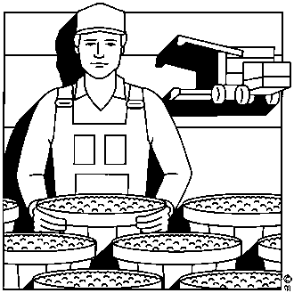
Dairy Belle Dairy Belle buys the milk from the farmer, checks it for content and cleanliness, checks for bacteria and so on in the milk, packages the milk and then sends it to Pick N Pay and other retailers. The business activity of Dairy Belle is the processing and packaging of milk and other related products. They are classified as wholesalers and form part of the secondary sector of business.


Transport The transport company collects the milk that has been packaged from Dairy Belle and takes it to Pick N Pay.

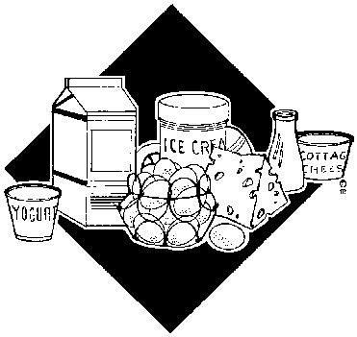
Pick N Pay Pick N Pay purchases the milk from Dairy Belle and packs it in the fridges for the consumer to buy. They are classified as retailers and form part of the tertiary sector of business. The business activity of Pick N Pay is the buying of products wholesale and selling them to the consumer at retail prices.

Consumer You, the consumer, buy the milk at a location close to you.

In this value chain of business activities, everyone, except the transport company delivers products. The transport company, of course, provides a service.
The whole purpose of this value chain is, of course, to bring the milk from the farm to you, the consumer, at a location close to you and in a packaging that is convenient to you.

Sub-sectors
The wholesale and retail industry can be divided into a number of smaller sectors or "sub-industries":
- clothing and footwear
- DIY
- Consumer electronics
- Office supplies
- Pharmaceutincals
- Sporting goods, etc.

Divisions of industry

Categories of businesses in the South African automotive industry
The automotive industry comprises the following role players:
1) Original equipment manufacturers (OEMs) or automotive assemblers. This category comprises both passenger and commercial vehicle assemblers.
2) Automotive component manufacturers (ACMs). The ACMs supply components to OEMs, original equipment suppliers (OESs) and the independent aftermarket. The ACMs can be seen as the first-tier supplier in the automotive supply chain.
3) Original equipment suppliers (OESs). This category comprises automotive parts and accessory sales through the OEMs.
4) Automotive retail and aftermarket. This category consists of automotive parts and accessory sales, through independent retailers and repair shops.
Among the manufacturers of automotives in South Africa are:
- • BMW South Africa
- • Ford South Africa
- • General Motors South Africa
- • Mercedes-Benz South Africa
- • Nissan South Africa
- • Renault South Africa
- • Tata Motors South Africa
- • Toyota South Africa
- • Volkswagen South Africa
Read more: http://www.southafrica.info/business/economy/sectors/automotive-overview.htm#.VnbNrpXqEmh#ixzz3usPaEUAW
The following vehicle manufacturing companies import their vehicles to South Africa
- Hyundai
- Honda
- Suzuki
- Volvo
- Kia
- Opel
- Daimler
- Ferrari
- Porche
- Jaguar
Passenger vehicles include:
- Sedan cars
- hatchbacks
- SUV: sport utility vehicle
- MPV: multi-purpose vehicle
Commercial or delivery vehicles include:
- LDV
- Light commercial vehicle
- Medium commercial vehicle
All these vehicles can be new or used

Industry Specific Information SO5 AC2
Read the following articles regarding the Automotive industry in South Africa for general background information
South Africa's automotive industry
South Africa's automotive industry is a global, turbo-charged engine for the manufacture and export of vehicles and components. Many of the major multinational firms use South Africa to source components and assemble vehicles for the local and international markets.
The sector is one of South Africa’s most important, contributing at least 6% to the country’s GDP and accounting for almost 12% of South Africa's manufacturing exports, making it a crucial cog in the economy. In 2010, 271 000 vehicles were exported.
More than 28 000 people are directly employed in automotive manufacturing, with 65 000 employed in the component manufacturing industry. About 200 000 are employed in retail and aftermarket activities, with 6 600 employed in the tyre manufacturing industry (Automotive Industry Export Council, 2010).
With its ability to link throughout the economy, the government has identified the automotive industry as a key growth sector. It already exhibited significant growth under the Motor Industry Development Programme (MIDP), doubling in size since 1994.
Its successor, the Automotive Production and Development Programme, which will be implemented from 2013, aims to stimulate the expansion of local production to 1,2- million vehicles a year by 2020 while significantly increasing local content at the same time.
The automotive and components industry is well placed for investment opportunities. Vehicle manufacturers such as BMW, Ford (incorporating Mazda), General Motors, Mercedes Benz, Nissan, Renault, Toyota and Volkswagen have production plants in South Africa, while component manufacturers such as Arvin Exhaust, Bloxwitch, Corning, Senior Flexonics have established production bases here.
The industry is largely located in two provinces, the Eastern Cape (coastal) and Gauteng (inland). Companies with production plants in South Africa are placed to take advantage of the low production costs, coupled with access to new markets as a result of trade agreements with the European Union and the Southern African Development Community free trade area. Opportunities also lie in the production of materials (automotive steel and components).
SAinfo reporter, incorporating material from the South African Yearbook
Reviewed: 27 November 2012
Read more: http://www.southafrica.info/business/economy/sectors/automotive-overview.htm#.VnbM85XqEmg#ixzz3usOe7pYf

Also visit the following link for an article about the passenger car market in South Africa:
http://www.engineeringnews.co.za/article/auto-industry-2015-11-20-1

Retail Legislation SO5 AC3-4

Consumer Protection Act
Much has been written about the CPA; its effects on business and consumers alike. Reading the Act is a major undertaking as it covers some 480 pages. We made a point of studying the parts which affect the used vehicle industry. In this article I will explain in simple terms how the CPA will affect you in terms of buying and selling motor vehicles.
The media has made a meal of the Act in that in many ways they have misled the public into believing they can return a car to a dealer within 6 months of purchase under almost any circumstance. I receive approximately 30 calls for assistance in connection with CPA issues each week and I have been appalled at the levels of misperception. What they (the media) have singularly failed to do is explain under which circumstances this may happen and what the ramifications thereof are. I am going to list some of the more important facets of the Act:

1. Disclosure:
The dealer must disclose any known faults in the vehicle to you and also list what he has done to the vehicle in terms of reconditioning. Note that these should be obvious faults. The dealer has to rely on his experience and mechanical knowledge to make a judgement call on a car's condition. It cannot reasonably be expected that the dealer must know absolutely everything about each car he deals with. In cases of arbitration the Ombudsman will most certainly always revert back to the issue of "reasonableness".
The dealer must also disclose the year of first registration as well as the code status of the car. i.e. New; Used; Imported; Stolen/Recovered; or Rebuilt. He has to allow you to inspect the vehicle and conduct a road test. The object of this clause is to ensure that the buyer is making an informed choice. The words “Voetstoots” and “As Is” are no longer permitted but of course, older, high mileage cars still need to get sold and these will now be sold as “scrap” but without a roadworthy certificate. If the seller has supplied a roadworthy certificate on such a car, it implies a six month warranty. Note that the intent of the word warranty within this context does not imply maintenance. It must match the criteria of "fit for the purpose for which it was purchased"

2. Wear and Tear:
The buyer will be required to sign that he accepts that he is buying a used vehicle and that it has a level of wear and tear and that it is not expected to perform like a new vehicle. i.e. The buyer will not be able to return the vehicle based on wear and tear complaints.

3. Right to return the vehicle:
The buyer may return the vehicle to the seller within a 6 month period under certain conditions. This is subject to Section 56 (2) of the Act. - Wear and tear is excluded. There has to be a proven defect in the car or the buyer must prove that the vehicle was sold to him which was not fit for the purpose for which he bought it. The onus will be on the buyer to provide evidence of such defect. The buyer has the option of requesting a repair, replacement or refund. The reasons for such an action have to be legitimate, reasonable and provable. A motor vehicle is a complex piece of machinery and will be treated differently to buying a fridge or a toaster, for example. It is very important to note that the National Credit Act has to fit into the CPA, so if the car you have bought is under a finance agreement, things will be a lot more complicated.
Since vehicles are goods which devalue with use, the purchaser will be liable for the usage of the vehicle, plus any damages he has inflicted on it, plus the costs of re-roadworthying the vehicle and getting it back into the dealer’s stock. For those naive buyers who thought they could buy a car from a dealer and hand it back after 6 months and keep going like that forever having a free car, well, sorry, but that is simply not a reality. There is also a certain time frame and a process for dispute resolution which has to be taken into consideration. The Motor Industry has its own Ombudsman to whom all unresolved disputes will end up with. It is expected that the time frame for resolution will be about 3 months.
In cases where refunds are given on vehicles, the buyer will be responsible for the difference in price attained when the vehicle is resold to a new buyer. These are all items the media have failed to inform the public of. My concern is that this will lead to unrealistic consumer expectations.

4. Cooling off period:
This is only applicable if the Offer to Purchase and/or Instalment Sale Agreement was signed at a place other than the seller’s premises or the finance company’s premises. It is also applicable if the vehicle was sold to the client by direct marketing. i.e. If the salesperson called you as a “cold call”.

5. Price:
The price of the vehicle must be fair, reasonable and just. The basic intention of the Act was to protect the poor and the uneducated segment of the population. This would be a very difficult law to apply in practice as in the case of vehicles they are all bought and sold very close to the book values, give or take a percentage for low or high mileage and/or condition. By definition the correct market value of a product is what one can get for it on a given day. Some cars command values far in excess of the book value and the public are willing to pay those prices if the product is in short supply. Conversely other products are not worth anywhere near the book value, but every car has a given price at which it will eventually sell. Thus it would be almost impossible to apply this part of the CPA to the sale of used cars, except in a very obvious circumstance.

6. Safe use of the product:
The client will now be required to sign a declaration whereby he accepts responsibility that a motor vehicle is a dangerous item and he will not be allowed to claim against the seller if he injures himself in using the vehicle after signing such a declaration.

7. The right to Documentation:
Buyers will be entitled to receive copies of all relevant documents relating to the purchase of the vehicle. He will be required to sign receipt of all those documents.

8. Implied 6 month warranty.
(Note how frequently the word "reasonable" is used in the Act. It is important to understand that the Act was written with the intention of it being applied within reason to all parties)
The CPA requires the seller to stand good for the reasonable durability of the vehicle for a period of 6 months. This is an implied warranty on defects. It is important to understand the difference between wear and tear and defects. Tyres, exhausts, brakes, clutch, etc., would be wear and tear, whereas a gear suddenly jumping out would be a defect. There is no mention of a mileage limitation. However, again, there are several clauses preventing abuse of this protection. It excludes wear and tear and normal maintenance; as well as misuse or negligence. It also specifies the word “defects”. This implies that the fault should have been (wittingly/or unwittingly) present in the vehicle at the time of delivery.
The buyer will need to provide proof to the dealer/finance house/Ombudsman of such defect. This is going to be costly and time consuming. The main beneficiaries will no doubt be the legal profession. Many dealers will not sell a car to you, without you purchasing one of the extended warranty products available on the market. It is also important to note that the Act does not require a seller of second hand/used goods to supply those goods with a written warranty.
Fortunately most dealers do provide a written warranty. In such a case, the warranty might be less than the 6 month stipulated period, or equal to it or even longer than 6 months. The vast majority of dealers will strongly encourage customers to purchase an extended after market warranty. By doing so, it would not in any way, reduce your rights as a consumer.
That covers the basics in terms of buying used vehicles. The wise buyer will carefully study the Act before embarking on a claim as it could end up costing him money to return the goods. Used vehicles are different to a new toaster bought at a supermarket. It is far more complex and hence the reason that the motor industry has been given its own Ombudsman. After all the dust has settled, I believe those dealers with a solid reputation will carry on doing business as before and will not materially be affected by the CPA, but the dubious or dodgy ones will be in for a tough time! The office of the Ombud is fully aware that there will be a certain type of “integrity challenged buyer” looking to take advantage of the Act and the industry has been assured that those types consumers have already been earmarked.
There will be a big increase in paper consumption. Most dealers Offer to Purchase document was a one page affair. It now runs into some 20 pages of terms and conditions, so a lot more forests will fall by the wayside as a by-product of the Act and a lot of lawyers will have lucrative additional work. Mostly when consumers are “the best protected in the world” it comes at a cost as when businesses are forced to close their doors, there will be job losses and tax losses for the state. At the end of the day, the cost of this legislation will be borne (once again) by the consumer.
Given that every single sale of any kind of product, or service, falls under the Act (with the exception of the State itself), the mind boggles at the sheer volume of complaints that will no doubt end op on the CPA’s doorstep. Of greater concern is how adept will the office of the CPA be? The Act itself and its specific conditions were only published two days after the Act came into force. This meant businesses were unable to modify their paperwork and policies in time. I would imagine that many complaints will be rejected in the first six months as the timing was clearly unconstitutional and infringed on the rights of business owners.
Time will tell and no doubt over time only the very worst cases will come before the Ombudsman. In the first week some 4000 complaints were received, of which the majority were against the City of Johannesburg (rates/taxes incorrect accounts) and the cell phone companies.

Addendum July, 2012 –
The Commissioner was recently interviewed on radio and gave the following statistics in terms of the CPA. Some 240,000 complaints were received by the CPA in the first six months. After 12 months the COA had successfully ruled on 6,800 cases. So, looking at some basic arithmetic, if we take the 240,000 cases and double it for one year, we have 480,000 cases of which 6,800 have been heard. That leaves a massive shortfall in unresolved cases. I am not aware of which plans have been put in place to close that gap, but I am willing to stick my neck out and say that it is going to take a very long time
http://autoadvice.co.za/auto/consumer-protection-act

Change owner or titleholder particulars for a vehicle
Any changes to the particulars of the vehicle owner or titleholder must be communicated to the appropriate registering authority within 21 days after such change. Use the notification of change of address or particulars of person or organisation (NCP) form.
When you sell your vehicle, you must notify your registering authority on the Notification of change of ownership/Sale of motor vehicle (NCO) form. The new owner must register the car in their name.
What you should do
- Go to your nearest registering authority.
- If you are changing your address, you must take along the following:
- A copy of your identity (ID) document if you are a South African citizen. If you are a foreign citizen, you must bring both the original and certified copy of your ID issued by your country of origin and your temporary residence permit.
- Proof of the new residential address.
- If you are a South African citizen, you must complete and submit form NCP only. If you are a foreign citizen, you must complete the NCP form and the Notice in respect of traffic register number (ANR) form.
- If you are selling the vehicle:
- The seller must complete the NCO form and submit it to their registering authority.
- The seller must hand over the registration certificate to the buyer.
- The buyer must complete the Application for registration and licencing of motor vehicle form (RLV) for submission.
- The buyer must submit the vehicle registration certificate, if the vehicle was registered in South Africa.
- Provide a mass measuring certificate if the vehicle’s tare was changed.
- The buyer of the vehicle must submit the forms at the registering authority within 21 days of buying the vehicle, along with the registration form obtained from the seller and the vehicle must go for a roadworthy test again (it is the responsibility of the buyer to ensure that the vehicle is roadworthy).
- If the vehicle is registered under a company, you must also submit a certificate of incorporation or name change as issued in terms of the Companies Act or a founding statement.
- The registering authority assesses your application and you must pay the fees as prescribed by your province.
- If required by the registering authority you will have to provide proof of the right to be registered as the titleholder of the motor vehicle concerned, e.g. an invoice or a sales agreement. If you do not have that, phone your nearest call centre or registering authority to establish whether they accept or require any other document as proof.

How long does it take
Applications are processed on the same day.

How much does it cost
Contact your local licensing office for the cost.

Forms to complete
- Notice of change of particulars (NCP)
- Application for registration and licensing (RLV)
- Notice of change of ownership/Sale of motor vehicle (NCO)
- Notice in respect of traffic register number (ANR)
Forms are obtainable from the registering authority or you can download them from the eNaTIS website.
http://www.gov.za/node/727526

Installment Sale
Under an installment agreement you buy an asset with a view to owning it at the end of the credit agreement. An instalment sale agreement may be structured to include a balloon payment; or the instalment payments can be equal over the entire agreement period, with no balloon payment. At the end of the instalment agreement, provided you have paid all amounts due, you will automatically become the owner and the title-holder of the asset. You need to contact Volkswagen Financial Services or we will contact you, to initiate change of title-holder and re-register the vehicle in your name.
The National Credit Act (NCA) implemented from 1 June 2007, does not govern true rental agreements. Ownership however will never pass to you.
A true rental agreement is a type of finance agreement where you are paying for the use of the asset. When entering into a rental agreement, you are not buying or leasing the asset with a view to owning it at the end of the credit agreement. At the end of the agreement you must return the asset to Volkswagen Financial Services. You must return the vehicle in good condition and within the agreed mileage restrictions and parameters. Should you exceed the restrictions you will be responsible for paying any restoration costs (except for fair wear and tear) and excess mileage costs.

Instalment Sale Agreement
An Instalment agreement means a sale of movable property where the payment of the full price of the goods is delayed and is to be paid out in regular payments over an extended and agreed period. The possession and use of the property is immediately transferred to the buyer, however, the seller remains the owner of the property and ownership only passes to the buyer on full and final payment of the price of the goods and when all the terms of the agreement have been met.

What an Instalment Sale Agreement offers me:
- Periods ranging from 12 to 72 months
- Interest that is calculated at either fixed or prime-linked rates
Please note that the goods must be fully insured during the agreement

What does an Instalment Sale Agreement entail?
- Ownership of the goods when you have paid the full amount
- If the asset is used for business purposes, you may claim depreciation and the yearly interest paid against tax
- You enjoy the benefit of any resale value
- Deposits are payable depending upon current legislation
- The goods must be fully insured during the agreement
You may want to consider taking the following option with your finance package:
- Take-A-Break Payment

Is there a way to lower my monthly instalments?
Yes, if you decide on adding a Balloon Payment to your overall repayment amount, your monthly instalments can be reduced. A Balloon Payment is effectively a way to postpone a portion of your payment until the end of your Instalment Sale Agreement. Once you reach this point, you need to pay a lump sum before the vehicle officially becomes yours.

My available insurance/warranty options are
- Comprehensive Insurance covers vehicle to protect the customer and FNB
- CoverPlus is shortfall insurance which covers the difference that is owed to FNB and the insurance payout
- Customer Protection Plan (CPP) covers the outstanding balance in the event of death or permanent disability
- Vehicle Warranty covers for mechanical breakdown after the manufacturer's warranty expires
- Retrenchment Policy pays up to 9 monthly instalments when you are involuntarily retrenched and remain unemployed
- Deposit Protector pays back your deposit if the vehicle is stolen or written off.
- Courtesy Car Policy (CPP) pays for the use of a courtesy car for 21 days if your car is stolen, written off or damaged
https://www.fnb.co.za/vehicle-finance/instalment-sale-agreement.html

Lease
Under a lease agreement, you lease an asset with a view to either returning the asset at the end of the credit agreement or, you can elect to take ownership of the asset on the conditions set out in the agreement (and once you have paid all amounts owing).
If you elect to buy the vehicle at the end of the agreement, (once you have paid all amounts due under the credit agreement) you will become the owner and the title-holder of the asset. You need to contact Volkswagen Financial Services or we will contact you, to initiate change of title-holder and re-register the vehicle in your name.
With almost a third of consumers now choosing to lease their vehicles in the US more than ever before, this method of financing is yet to properly catch on in South Africa.
According to credit information firm, Experian, 31.5% of new vehicles financed in the US in first quarter were leased – an all-time high, and up from 24% just five years ago.
The concept is relatively new in the country, but it can be seen as an attractive option amid rising interest rates, petrol prices, inflation, and a weakened Rand.
According to Wessel Steffens, head of Absa Asset and Vehicle Finance, leasing is still relatively uncommon in the South African retail market.
“We find that consumers still lean chiefly towards ownership of a vehicle, as they see this to be an investment, and in some cases as an achievement or affirmation of their self-worth,” he said.

Explanations
Absa pointed to three key financing methods available to South Africans:

Installment sale:
- This finance facility allows a person to buy vehicles and other assets, and pay for them over an agreed period.
- The benefit is that ownership will pass to the consumer automatically once they have made the final payment.
- Owning a car also carries none of the economic penalties or mileage restrictions experienced with leasing and renting.

Lease:
- A lease agreement is not only available to companies, but also to individuals and self-employed people.
- The lease agreement allows the customer uninterrupted use of the vehicle rather than ownership of it.
- You can choose to take ownership of the vehicle or return it to the bank at the end of the agreed period.
- You can drive a brand new car every two to four years and benefit from the safety, fuel economy and performance advancements found on newer models.
- For business owners who use the vehicle in an income- generating capacity, the repayments are tax-deductible.
- Balloon options are also available under lease and instalment agreements – you will be obligated to pay this at the end of the term, but you benefit from reduced monthly payments.

Rental:
- A rental agreement is available to individuals and offers you varying repayment periods like annual or quarterly.
- Like a lease agreement, a rental agreement allows the customer uninterrupted use of the vehicle rather than ownership of it.
- To reduce monthly payments, the customer can negotiate a residual value. Residual is normally the asset risk accepted by the bank as long as certain return conditions are met at termination of the rental.
“Each finance method provides different benefits to the client which vary based on whether you require ownership of the vehicle, whether the vehicle will be used to generate income, or whether you are a registered VAT vendor,” Steffens said.
“Lifestyle and life stage also play a big role in the option selected.”
Rudolf Mahoney, head of brand and communication at Wesbank said that traditionally, South African buyers have tended towards the conventional finance model, whereby money is borrowed from a bank to purchase a vehicle.
“Over the last year and a half WesBank has seen an increase in the number of offerings in the market that allow consumers to acquire vehicles through leasing or lease-type finance agreements. The majority of these offers are at the higher end of the market, from premium brands,” Mahoney said.
According to Wesbank, the main difference between a lease and a purchase is that the motorist will not own the vehicle at the end of the term.
Traditionally, lease contracts are for shorter terms – usually 36 months – while a vehicle finance contract can be between 12 and 72 months, depending on the buyer’s affordability.
Leases work on the premise of a large future value – or a residual value. These larger residual values make monthly repayments more affordable, the financial firm said.
At the end of the term the vehicle is then returned to the financier, at which point the financier will dispose of the vehicle in order to settle the residual value.
“The costs of leasing can be far lower than those associated with traditional vehicle finance, given that in some instances a residual value can be up to 60% of the cash purchase price of the vehicle,” said Mahoney.
Consumers forego the traditional costs associated with credit, and since lease periods are usually around 36 – 48 months, they do not have to be concerned with service and maintenance costs. These would be covered by the manufacturer’s warranty, service, and maintenance agreements, he said.
Wesbank noted that leasing is ideal for more discerning buyers who wish to drive modern vehicles, with the intention of replacing them on a regular basis. “When a lease expires consumers don’t have to be concerned with selling or trading in a vehicle they no longer want, nor will they have to worry about settling any outstanding fees or shortfall amounts,” Mahoney said.
For buyers who wish to remain free of debts or monthly payments would be better served by conventional finance, through which they can pay off and take ownership of a vehicle, until such a time as they need a replacement.
Wesbank warned that a lease agreement will often have strict limitations and penalties for the motorist. These will require drivers to stick to service schedules, approved repairers, and mileage limits.
The vehicle’s future value is affected by these factors. In many cases buyers may be required to limit total distance travelled, or face a penalty fee for each kilometre travelled beyond the agreed-upon distance, Wesbank said.
Businesstech website

SECTION 2: SALES PROCEDURES AND BUYING SIGNALS

Specific outcome 1
Identify early buying signals and act thereupon.

Assessment criteria
- The characteristics of early buying signals are described, as is applicable to a specific industry
- The reaction to early buying signals is demonstrated according to organisational procedures in a structured scenario
- The standard company sales procedures are explained in terms of obtaining a prospective buyer's commitment

Essential Embedded Knowledge
- Product knowledge, FABs (Features and benefits), communication skills.
- Selling skills (buying psychology).
- Add on products and services
- Organisational policies and procedures
- Conflict handling skills.
- Identification of buying signals.
- Features Advantages Benefits

CCFO
Identifying: Identify and solve problems in a critical and creative way when presenting products and services to the customer in such a way that is conducive to a successful sale
Organising: Organise and manage oneself and one's personal activities responsibly and effectively.

Buying Psychology (EEK)
There is a certain psychology involved in buying.
Humans have various needs and buying impulses and our decision to buy something is a mixture of emotional impulses and logical facts.
For example, if you are buying a car it would depend on what you need: you decide that you need a car to transport the family to school, work, vacations and so on. This is logical. Now you do research, these days people can browse the Internet to find their ideal car.
You see a SUV that is just gorgeous, but there is also a van-type vehicle available. You will now use a mixture of emotions and logic to help you decide that you need the SUV. You will, for example, compare:
- the specifications of the two vehicles
- safety features
- fuel economy
- Prices
If your budget allows, you will probably go with the SUV – an emotional decision, backed up by logical facts.
What this means for you as a salesman, is that you have to tap into the emotional need of the customer and back up his decision through logical facts.

What is in it for me?
Buyers always want to know what they will gain by buying this product or service. You therefore have to consider the buyer’s ego by explaining to him what he stands to gain by buying from you.
Buyers are more concerned about not losing any money than they are about gaining something from buying this product
You have to show the customer that he will be better off with your product: in other words he is not going to lose anything, instead he will be gaining.
For example, by buying the SUV he will not really pay that much more than on the other vehicle, while the advantage of being able to travel on all roads is a definite gain.
Buyers tend to be suspicious of sales people
This is because they have been lied to in the past. In order for you to convince your customer that they can trust you, you will have to establish a relationship of trust with the customer.
You do this by not lying to the client, explaining pitfalls of the transaction and making sure that you know what the customer wants before you make suggestions.
As buyers we also relate to visual images
When you start looking for a car, you have an idea of what you need. Your next step is to find a car that is visually appealing and then you look at the facts. Nobody buys a car that he does not find good to look at. This is why cars come in different shapes and sizes, colours and accessories.
A success story from the past that hooks into the visual image will further appeal to the buyer. We love to hear success stories: of how this SUV was able to drive through mud when it rained so much that everyone else was stuck. This appeals to the logical side where we want facts.
Buyers want value for money
As a buyer, we all want as much value for our money as possible – we want a bargain. What is important is to remember that the concept of value differs from person to person – some people want a discount, some people want something added to the deal, others would negotiate for lower interest rates, and yet some others want specific colours or accessories.
Peer pressure
As human beings we are influenced by what other people are doing, we don’t want to be left out or feel we are being left behind.
Telling true stories of other people have benefitted from this car or how popular the vehicle is or even how this vehicle met the needs of other buyers will assist you to convince the client to buy.
In conclusion
Following the selling process and using the right tactics are necessary, but you should also keep the psychology of buying in mind while negotiating a sales deal.

Sales Philosophy (EEK)
Blankenship the Vice President of Sales & Ownership Experience at Tesla, reinvented the car buying experience with a 3-step philosophy: surprise, entice, inform.
Surprise includes the way you greet a customer, the way the store is laid out, where the store is situated and even how you advertise the store
Entice: this is how you entice customers into your store. What do you do that is different to what other car dealers are doing? How is your store different to other stores? What extras do you add to attract customers? Do you offer something to drink? Do you have something in the store that can occupy the children while you are negotiating with the parents?
Inform: how do you keep your customers occupied while they are waiting for a sales consultant? Do you have exhibits, touchscreens, TV with videos about your products?
Read more at the following website to find out exactly how Tesla are accomplishing the above 3 experiences.
http://www.forbes.com/sites/carminegallo/2012/01/11/former-apple-retail-exec-reinvents-the-car-buying-experience/

Features, Advantages, Benefits (EEK)

Product Knowledge
When communicating with customers, you must have an in depth knowledge of the products and services of your organisation.
If you are working for an IT company, your products and services could include personal computers, software, installing and maintaining of networks, Internet access, advice on the best system for a specific customer and so on. When you work for a bank, on the other hand, the products and services would be savings accounts, cheque accounts, investment accounts, loan accounts and credit cards. Advice would be financial and investment advice. A furniture retailer’s products and services would be electrical appliances, furniture, delivery, granting of credit, special offers, etc.
You must be able to describe the physical specifications of features, advantages and benefits of the product to the customer.
If we use a furniture store as an example, if a customer enquires about a stove, you must be able to describe the stove:
- Electrical or gas
- Colour
- How many stove plates
- How big is the oven
- What are the dimensions of the stove – height, width and depth
- How quickly does the stove heat up
- Price
- Guarantee
- Cash discount
- Monthly repayments if taken on credit
In the case of an insurance company, you have to be able to describe:
- Life policies
- Endowment policies
- Retirement annuities
- At what age is which product best for the client
- What are the ideal monthly contributions in relation to the customer’s income
- What are the benefits to the customer

Product Features, Advantages and Benefits
In sales, you probably have heard or will hear the saying: “People don’t want to buy a quarter-inch drill, they want a quarter-inch hole.”
This quote by Theodore Levitt is probably one of the most quoted passages in marketing in trying to explain the difference between features and benefits.
We can take this quote further by thinking about the purpose of the hole: What does the customer plan on doing with it? Even better, what’s the end-result the customer wants to achieve with it?
The answer to that question would be the real benefit: the ultimate benefit. Not the hole. And certainly not the drill that created it, but the painting the customer want to hang.
If we look at the definition of benefit in a dictionary, we will see that it reads: “something that improves, enhances, or promotes well-being.” So, how is one or one’s well-being enhanced by a quarter-inch hole?
Features are unique characteristics that your product has to offer a prospect.
They are often listed on the retail box or placed on sales pamphlets that are left with the prospect. Many times they are bullet point after bullet point of exactly what your product or service provides.
Without Features your product would look just like everyone else's product in the marketplace.
Benefits are what the unique characteristics of your product can actually do for a person or business.
Benefits are how your features will help the prospect conduct their business in an easier, faster, or even more profitable manner.
When selling, we are always told to sell benefits, not features.
We will use the following extract of an on-line advertisement for Miele ovens to explain this:
“The Miele fan forced cooking system, for example, enables you to cook on up to three levels. Rather than just circulating hot air with a fan we use a mini-turbine together with a ring heater element to force hot air evenly throughout the oven interior. This reduces cooking time and thus energy consumption – above all providing perfectly even cooking results.”
In this advertisement, the feature, advantages and benefits are:
- Features: Fan forced cooking system, mini turbine, and ring heater element.
- Advantages: Cooking on up to three levels, hot air forced evenly through the interior.
- Benefits: Reduced cooking time, reduced energy consumption, perfectly even cooking results.
In other words:
- Features describe the sales item in technical terms.
- Advantages describe the sales item in terms of what the feature does.
- Benefits describe the sales item in terms of the benefit to me, the customer.
Whilst features and advantages are a function of the product or service, benefits are solely in the mind of the customer.

Example one
I have a hot water system. The system sprang a leak last night when the glass cylinder lining the tank cracked. I have family about to arrive on my doorstep for Christmas holidays and the house will be full.
In this example, the benefit uppermost in my mind is hot showers for everybody. The advantage is that you can install it before my family gets here. The feature I am interested in is your installation service. Which brand, gas or electric and what level of temperature control I can have are secondary to my desperate need to have a new system installed quickly.

Example two
I am, for all intents and purposes, a geek. I love technology. I know what technology can do and so do all my friends. I am about to buy a new computer.
In this example, the features themselves enable me to brag about my computer to my friends.

Example three
I am a mining maintenance manager. My finance manager has been very vocal in the need to reduce costs and wants me to reduce our maintenance schedule. I know this will result in higher levels of breakdowns and eventually higher costs and lower production. My professionalism will not allow me to reduce the maintenance schedule, but it may cost me my job if I don’t lower costs within the next six months. I am about to let your company tender for the lubricant supply for our company.
In this example, your ability to supply lubricants that really do reduce metal wear and fatigue will give me the benefit I need of reducing maintenance costs without compromising my integrity.

Example four
I am a busy working mother. I have to get up at 6:00 am in the morning to water the garden. Then I have to get the kids ready for school and myself ready for work. I am considering putting in a watering system.
In this example, an automated system will deliver the direct benefit of an hour extra of sleep.

Notes
Whilst it is true that we should sell benefits not features, or even advantages, it is dangerous to develop benefits based on the features and advantages of a product or service.
In the hot water example above, demonstrating the dual temperature control and continuous flow of hot water is not as compelling as saying, “I can have it installed this afternoon”.
In the mining example, you would have to show me a case study where your products had lowered maintenance costs by reducing metal wear. Also you would have to help me make the case internally with the finance manager.

Product features
Product features are physical characteristics of a product sold and marketed by the company.
It includes qualities or variables such as shapes, size colour weight, speed, durability, and maintainability.
Marketers often draw distinction between product features and the product benefits. While features exist in the product by itself, benefits is the nature of value that a customer derives from the product because of features.
While the features of a product remain same irrespective how or by whom the product is used, benefits depend on the product features as well as what the customer needs and values
This example will explain product features. If you want to assist a customer with enquiries about this product, you have to know all the features of this product.
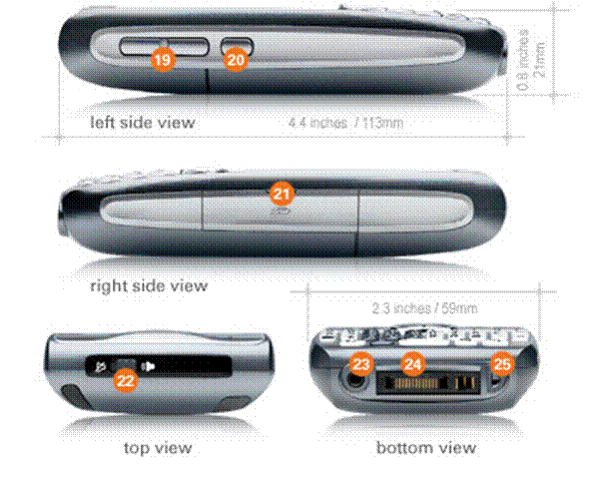
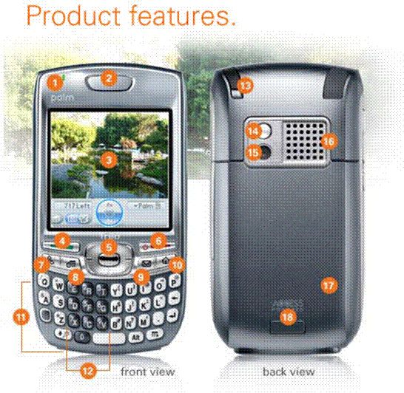

1 Status Indicator | 2 Phone Speaker
3 320x320 Colour Screen | 4 Send Button
5 5-way Navigator | 6 Power/End Button
7 Phone Button | 8 Calendar Button
9 Messaging Button | 10 Applications Button
11 Easy-Type Keyboard | 12 Phone Dial Pad
13 Stylus | 14 Self-Portrait Mirror
15 Digital Camera | 16 External Speaker
17 SIM Card slot | 18 Removable Battery
19 Volume Button | 20 Customisable Button
21 Expansion Slot | 22 Ringer Switch
23 Headset Jack | 24 Multi-Connector
25 Microphone
Another example of the features of a product:
Dual Intelligent Processors 2 with DIGI+ VRM


Digital Power Design: The New Standard
The world’s first Dual Intelligent Processors from ASUS pioneered the use of two onboard chips - EPU (Energy Processing Unit) and TPU (TurboV Processing Unit). New generation Dual Intelligent Processors 2 with DIGI+ VRM digital power design launch control into a new era.
The digital architecture delivers twice the precision power, intelligently adjusting PWM voltage and frequency modulation with minimal power loss through BIOS tuning and an exclusive user interface to increase the board’s overclocking range while performance reaches its full potential. It also adjusts VRM frequencies dynamically, cutting radiation interference by half and decreasing Vcore power noise for CPU to enhance system stability through enabling VRM spread spectrum. ASUS DIGI+ VRM digital power design empowers users with superior flexibility and perfect precision to ensure optimized performance, extreme system stability and greater power efficiency.

Features can be further broken down into the following 3 categories

Standard features
Standard features are features which are associated with every instance of a product. An example might be the brand name of a product -- all instances of the product share the same brand name.

Selectable features
Selectable features are features which the customer selects one from many available choices. For example, a shirt may be available in White, Blue, Green, Yellow, Pink. These colours would be selectable features of the variant product shirt, and the customer would be prompted to choose a colour.
Each colour, though, would be a standard feature of the physical product. Thus, White would be a selectable feature of the virtual product 'shirt' but a standard feature of 'white shirt.'

Distinguishing features
Distinguishing features are features which distinguish one product from another and are used to show the customer which item she chose.

Benefits

If Features are line after line of unique characteristics that your customers may need, then Benefits are the hooks that catch the customers and makes them want your product over your competitors.
A feature is:  - Physical size  - A 75 horsepower motor  - Patented box spring design | A benefit is:  - Small enough to fit in your raincoat pocket  - A mower that takes the work out of yard work  - A restful night's sleep
While product features are usually easy to detect and describe, product benefits can be trickier because they are often intangible. The product benefits that encourage a customer to buy are those that provide emotional or financial rewards.
It is not the brighter smile that the toothpaste offers that is its benefit; it is what the smile might bring you: friends, a better job.
Emotional rewards allow the buyer to feel better in some way. For example, sending flowers to a friend or family member allows the buyer to express love. Buying products made from recycled materials offers the buyer the chance to be environmentally responsible.
Products that deliver financial rewards allow the buyer to:
- Save money (a discount long-distance phone plan)
- Make money (computer software for managing a home-based business)
- Gain convenience and time (microwaveable meals).
To identify your product's benefits, you need to look at the product from the customer's viewpoint. You can also ask your customers why they like the product, they may identify benefits that you have not thought of. Or, the customer may not see the benefit that the product was designed for.
Look at the customers who have purchased your product in the past. What does that customer profile tell you about your product's benefits? If you don't have that information, in the future you might set up a few systems to develop and track the following information:
- Ask customers for suggestions for improvement.
- Pay attention to customer complaints and prospect inquiries. Listen to what your customers say. Train and reward employees for listening to customers and prospects to learn what they want and what they don't like about your product. Analyse and learn from this input.
- Watch your competitors. Do the changes in their product offerings suggest desired product benefits?
Understanding product features and benefits helps you develop your marketing strategy to better:
- Describe your products in a way that is most relevant to customers
- Differentiate - explain how your product is differs from other products in the market
- Use a variety of pricing and positioning strategies effectively
Products may be highly unique (specialty products) or virtually indistinguishable from competitor's products (known as commodity products). Specialty products are not necessarily better than commodity products, but they do require different marketing strategies. An important strategy for specialty products is differentiation. A company differentiates its products when it sets them apart from the competitor's products in the minds of customers. Having a thorough understanding of how your product's benefits compare to your competitors allows you to compete with them through differentiation.
Take a look at the list of features below, taken directly from current advertising and marketing materials.
- Self-setting clock
- 50-number speed dial
- One-click financial reports
- Custom programs
- Open 24 hours
- Batteries included
Each is a feature-a factual statement about the product or service being promoted. But features aren't what entice customers to buy. That's where benefits come in.
A benefit answers the question "What's in it for me?," meaning the feature provides the customer with something of value to them. So that must mean:
- The benefit of a self-setting clock is convenience.
- The benefit of 50-number speed dial is fewer keystrokes.
- The benefits of one-click financial reports are immediate information and prepared statements for your accountant.
- The benefit of custom programs is that they're designed just for you.
- The benefit of a store open 24 hours is you can buy when you want.
- The benefit of batteries included is the product is ready to use out of the box.
While these may seem like true benefits, they're really just elaborations on the features. So what is truly a benefit?
The best way to understand the true benefit of your product or service-or to answer the "What's in it for me?" question-is to focus instead on results.
A customer's perception of each feature's results is what attracts him or her to a particular product or service. When someone chooses a VCR with a self-setting clock, the assumption is that the benefit is convenience, but the actual results are that they don't have to read the instructions, watch a blinking 12:00, and, most important, feel stupid. Those results are the true benefits.
When you try to sell the features of your product or service, you're making the customer do all the work to figure out why they want the feature. It's in a seller's best interest to draw the connection for them. But to do that, you have to know the results yourself. Let's take another look at that features list to see the possible benefits from the customer's point of view:
- Self-setting clock: I won't feel dumb!
- 50-number speed dial: I can keep in touch with my best customers without effort, and I won't get frustrated misdialling.
- One-click financial reports: I can see exactly where my business is financially at any time. I can spend more time with my family instead of trying to figure out whether I'm making enough money or not. I can see business what-ifs instantly.
- Custom programs: It will accomplish exactly what I need, and I won't have to worry paying for services I don't want.
- Open 24 hours: When my pregnant wife craves pickles and ice cream at 4 a.m., I won't have to disappoint her.
- Batteries included: I'll never have to see the crushed look on my child's face when his toy won't work because I forgot to buy batteries.

Develop benefits from your knowledge of the target market.
- As a sales person in a consumer market this means asking probing questions to uncover the benefits the customer seeks.
- As a sales person in a commercial market, this means perhaps, uncovering the benefits several people in an organisation seek.
For example, when selling to the mining industry:
In general, in an open cut mine, for example, the finance manager worries about the cost of the supply contract. The mining manager worries about overall costs of producing a tonne of ore. The maintenance manager worries about the cost of maintenance. The mine planning manager worries about the available time of the serious equipment – draglines and electric shovels. The environment manager worries about run-off into the environment. The operator worries about not being inconvenienced by downtime and by personal discomfort and also about safety.
Selling and following up to the mining industry requires communications which target all of these decision makers and influencers each with a different benefit.
Benefits sell products. They are derived not from the product, but from the customer’s environment and mind set which may change at any given moment.

Advantages
To feature and benefits the intermediate position of attributes or advantages is sometimes added.
Attributes are intangibles that are associated with the product, not the person (and hence are not yet benefits).
Thus, for a hi-fi amplifier:
- A feature is the large volume control.
- An attribute is the maximum decibels of volume that can be achieved.
- A benefit is that high volume lets you immerse yourself in the music.
Some products have many attributes whilst others have far fewer. One way of identifying attributes is to look on the product specification. Customers often have attributes on their checklist (rather than physical features or benefits).
Attributes are a useful stepping-stone between the physical product and the benefits that the person actually receives and can be used in a sales pitch as such.
In most descriptions that cover features and benefits, but not attributes, the attributes are usually described as features, although the non-tangible element means they are easily confused with benefits.

Advantage
The advantage that a product has may well be in comparison with what a customer has already. You can thus ask a customer what they do or use now, then show how the product you are selling offers advantages over the current method.
Advantages may also be presented as a comparison with competitor products. If the customer talks about a competitor product, you can show the advantages that your product has over the competitor product (and perhaps how these are more important for your customer).
As well as advantages, you can talk about disadvantages of their current approach or competitor products. Be very careful with this, as you may easily appear as critical of things they value and hence provoke objection and argument.
A second version of the word 'advantage' is an assumed or undeveloped need that the sales person has identified but the buyer does not yet recognize.
The job of the salesperson here is thus to convert advantages into the benefits that are recognised and desired by the customer.

Selling benefits and features
So now that you understand the difference between features and benefits, how do you apply this to your job so you can start marketing your benefits?

Know your customer
In order to know which benefits your client will be interested in, you have to know your client – what your client wants and needs.
If we use cell phones as an example,
- older clients want to be able to make and receive phone calls, send and receive photos and maybe send SMS’s,
- while younger clients want to access the Internet, send e-mails, and anything else that the latest technology has to offer.
This means that telling older people about easy Internet access won’t sell the product, but telling them how easy it will be to access messages and send and receive photos will be a benefit that they will be interested in.
Your customer’s preferences will be determined by:
- age
- gender
- income
- interests
- health
- whether they are working or not
- the area they live in, etc.
To know your customer, you must gather as much information as possible on each market segment. You have to gather
- demographic data: age, gender, household income, family size, number of credit cards, media preferences and so on
- and psychographic data value system, , behavioural style, response mechanisms, fears, passions and so on.

Market segments
Dividing customers into groups based on demographic and psychographic data is called segmenting the market: market segmentation.
When you do this it enables you to focus only on those groups of customers who will be interested in the product – the target market.
Demographic data
The demographic factors describe the customers and tell you who your customers are. The most commonly used demographic factors are:
- Age: the products children and young people buy are different to the products that adults and older people buy. Children and teenagers would not be potential buyers of cars, while young people would prefer to buy sporty cars. Adults with children would buy family cars while older people who are nearing retirement age will prefer to buy a car that will last them until they die and is not expensive to maintain.
- Income bracket: the income level of the market segment determines how much they can spend on necessary things and how much they can spend on luxury items such as going to the movies or buying a bigger car or even new furniture.
- Ethnic origin: people from different ethnic origins buy different products. Something as commonplace as washing powder to wash clothes in can be determined by ethnic origin. However, an easier example is to look at food. Different ethnic groups have different preferences for food. Some ethnic groups prefer to eat pap rather than salads, some eat lost of pasta with a little bit of meat, others eat lots of meat with just a little rice or potato. Americans eat a lot of fast food during the day, mostly hamburgers and coke or sandwiches, chips and coke, while South Africans prefer other dishes.
- Gender: women buy different products from men. Women are usually responsible for buying household products such as food and cleaning materials, clothes, furniture and so on. Men have different responsibilities and therefore buy different things. Men buy cars, alcohol, tickets for the theatre and so on.
- Community: the community in which people live also influence their buying decisions. Products can be fashionable in a certain community while it is unfashionable in another community. Mini-dresses are a good example. If you live in a very conservative community, buying and wearing mini-dresses will be frowned upon. On the other hand, if you live in a younger, more fashionable community, everybody will be wearing mini-dresses.
You can get much of the demographic data from studying your present customers. You can probably guess
- their age and health from their appearance,
- their family and marital situation from their conversations,
- their economic level from the way they dress and their behaviour, and so on.
When you have only phone contact with your customers, it becomes more difficult, this is why you should refer to the customer’s profile of file, where you will find the information you need. Working in a call centre, you will have already have certain details of the customer on record, for example an ID number, address and gender. From the ID number you can determine age and from the address you can determine the probable level of income of the customer.
Why are demographic data so important? People who earn more, tend to buy more expensive and luxurious products, while women buy different products from men. You would find it difficult to sell a new brand of washing powder to a man – this is an area where women will recognise benefits. On the other hand, it would normally be easier to sell a certain type of oil to a man who will recognise the benefits.
Children have different needs to adults, old people to middle age people and poorer people to richer people.
Psychographic data
Psychographic data is a little more difficult, but you can gather some from observation. For example, finding out what kind of car a person drives as opposed to what kind they wish they had will tell you much about what they value. If they drive a station wagon and long for a red convertible, then you could presume that they fantasise about freedom and lack of responsibility. If you know they prefer classical and jazz to pop or country, they may consider themselves apart from the crowd or they have a broad background. These aren't observations are not absolute or 100% accurate, but when you put together a number of such facts, it's possible to obtain a reasonably accurate picture of what motivates an individual.

Change your point-of-view
Whenever you function from your own point of view, you automatically fill in the blanks with assumptions. Unfortunately, prospects can't do that. No matter what type of company you work for, you're bound to think it's great because you fully understand what you're offering. But a prospect knows little or nothing about your offerings. That's why they can't make the same connections about it that you can.

Selling benefits
Benefits are what the customer gains by using the product. When using a hi-fi system, they get to hear beautiful music, faithfully reproduced in their living room, with sound as real as if they were in a live concert.
Selling on benefits thus means selling to what they really want, not what they say they want or what you want to sell.
With benefits, you can get them excited and emotionally engaged. With features, you can only get nodding heads and logical agreement.
Features, when discussed can also be talked about in terms of benefits. With a graphic equalizer they can compensate for booming resonances, further refining the sound and improving the experience. With great signal-to-noise, they can turn the sound up and hear a pin drop, not a nasty hiss.

Example #1.1
Prospect: "Jimmy thanks for hearing me out. I appreciate that you call month after month trying to get my business. But as I told you countless times before I need the new computer you are trying to sell me to be at least 3Ghz."
Average Sales Rep: "Mr. Smith as I have mentioned before my new dual core computer runs at 3.5 GHz and has 2 GB of Ram. It has the fastest video card produced and comes with dual monitors for free."
Prospect: "Jimmy I just need to shop around."
Average Sales Rep: "Please do; you will find our product is the best. Do you mind if I follow-up with you?..."
What happened? Why didn't Mr. Smith buy the new computer? All of the features that he needed were there. They were all uncovered correctly in the probing section of the sales cycle. Still - no sale?
The opportunity for the average sales rep is to realize that prospects do not buy on features alone. They need to be convinced that
- A: They actually need those features, even though they said they needed them, and
- B: That those features can do something that can help the prospect advance his/her business.
Professional sales reps take a widely known secret and use it on every call. Prospects do not buy on features alone they buy on the benefit that those unique characteristics provide.

Example #1.2
Prospect: "Sammy thanks for hearing me out. I need the new computer you are trying to sell me to be at least 3 GHz."
Professional Sales Rep: "Mr. Smith I understand the need for computing speed in today's marketplace. The features of my product go above and beyond what your business needs. However my product will also benefit you by allowing you to be much more productive which should in turn allow you to leave the workplace at a normal hour. Not only will you be able to leave work on time but your stress level will probably drop in half with this much computing power."
Prospect: "I certainly want better working hours and less stress. So you can give both of those to me...?"
The point of the two examples is that prospects rarely buy on features alone.
Features just fill the prospect’s needs. Professional Sales Reps realize that they have to make their prospects want their product and their product only. So they make their prospect want their product by showing how the benefits will actually improve that person's business or in the case above improve their life.
Really, who doesn't want better hours, or better working conditions? How about something that saves them money? It's not the features that will make the sale, it is what those features will do for the individual you are selling that will allow the deal to progress.
You need both features and benefits in the sales cycle. Typically you will be defining a customer’s needs in the probing cycle. You will be evaluating which of your product's features would best help fill the customer's needs while you are probing.
Then during the pitching section of the sales cycle you will restate their needs and make them want your product. How do you make them want it? By showing how your product benefits them as an individual. By painting a picture with the benefits the prospect will actually want your product over your competitor.
If you are an average sales rep start listening to your pitch. Did you list out all of the features of your product during the call? Or, did you paint a picture of how those features will benefit the individual you were talking to?
It's not "features & benefits," it's identify which features they need then provide them the benefits of those features!

Link Features, Advantages and benefits

The Product Analysis Worksheet
The book “Personal Selling: An Interactive Approach,” by Ronald Marks, Ph.D., a professor of marketing at the University of Missouri, discusses the ability to convey benefits over features using a tool he calls Product Analysis Worksheet. The way it works is quite simple.
Product benefits usually consist of four principal levels. They are features, advantages, motives, and benefits. Each layer has its own set of attributes and characteristics, which varies depending on the product type and the market to which the product caters.
To illustrate, here’s a description of each layer:
- Features — what products have. For example, say you sell an accounting software. You can say, “This accounting software has a reporting feature.”
- Advantages — what features do. To continue our example, “Reporting provides real-time, on-demand, updated mission-critical information to key personnel.”
- Motives — what motives do features satisfy. For example, “Cost-savings, greater control, increased production, better decisions, etc.”
- Benefits — what those features mean. This is where you attach the advantages you outlined to specific motives those features satisfy.
The worksheet allows you to dig deeper and communicate what benefits really mean to your audience, it adds weight, purpose, meaning, relevancy, and power behind the benefits you initially come up with. It gives your benefits legs.
Obviously, coming up with a list of benefits may be easy if you know your product well enough. But describing them in a way that’s appropriate for, and directly related and targeted to, specific audiences is not an easy process.

Here’s how it works…
First, list all of the features of your product or service, including standard, technical, supportive, even abstract features. Then, with each feature, develop a subsequent list of relative advantages. Write down what each feature listed does.
Some people think that what a feature does is the benefit. But this is where most sales people fail to relate those benefits to their readers.
They assume an advantage is a benefit and stop there, when those benefits are too broad or one-sided. Instead, the feature’s function or purpose, not how it actually serves, relates to, and benefits the reader, is merely an advantage.
A feature is what a product has, an advantage is what that feature does and a Benefit is what that feature means.
A benefit is what a person intimately gains from a specific feature. It’s the ultimate end-result. When you describe a feature, say this: “What this means to you, Mr. Prospect, is this…” Followed by a more personal gain your reader gets from the feature.
Turn it around. Don’t focus on a certain feature’s benefit. Rather, focus on how those features specifically benefit the individual and what those benefits truly mean.
Here’s an example from a website where the customer has access to videos of someone tearing sales copy apart, and revealing copywriting tips, tricks, and actual, tested conversion strategies in the process.
- Feature: Watch a top copywriter in action as he writes killer copy, all recorded on video, using real salesletters and real websites from real clients.
- Advantage: You get to learn how to write copy faster by understanding the logic behind successful copy (not just how to write it), and also learn copywriting tips, mistakes, shortcuts, and proven split-test results in the process.
- Motive: What you want is to reduce the learning curve, risks, effort, and costs involved in trying to do it all yourself. Therefore, what this feature means is this…
- Benefit #1: This means you get real-world examples from real case studies and actually see the process done before you, instead of plain textbook theory or mere swipe files that leave you scratching your head.
- Benefit #2: Using real-world examples means you can understand what goes into world-class copy and appreciate how they’re being used, so you can easily repeat the process on your own, in the future.
- Benefit #3: Repeating the process on your own means you don’t have to pay an expensive copywriter to write it for you or fix it if it’s not performing well.
- Benefit #4: Not having to pay for a copywriter means you save money and get it done faster by learning proven strategies you can apply immediately, without waiting for someone to do it for you or explain it to you in some “how-to” course.
- Benefit #5: And learning proven, tested strategies means you eliminate the need to search for, find, test, and learn everything yourself, and avoid making costly mistakes by having to figure out what works and what doesn’t on your own.
… And on and on.

Can You See The Difference?
Now, once achieved, look at your worksheet.
Did you cover all the benefits that a specific feature has? Did you go deep and specific enough? Don’t just resort to apparent or obvious benefits. Dig deeper. Think of the end-results your readers get from enjoying your product or service.
Coming up with the first batch will be easy because they will be at the top of your mind. But forcing yourself to dig deeper and come up with stronger, more intimate benefits, although it will be more challenging, will provide you with some of the best ones.
To help you, here’s a simple exercise.
Once you’ve listed one benefit tied to a specific feature, just keep asking, “What this means to you is this…” And work it until you run out of reasons.
Or add the words “so that” at the end, like, “With this feature, you get [benefit], so that [deeper benefit], so that [even deeper benefit],” and so on until you can’t go any further.
Once you’re done, you then move onto the next feature.
Remember that features tell but benefits sell
Above all, make sure you communicate those benefits in a way that truly reflects and caters to the situations, problems, needs, and desires of your target market. Express benefits in terms that relate directly to each individual in that market.
Benefits are effective tools to get your customers to fully understand and appreciate your product’s true purpose, meaning, and relevancy.
Think of what a feature means to the customer and the words that communicate this meaning at an individual, intimate, and emotional level.
Because the more intimate your benefits are, the more real, vivid, significant, and meaningful they will be. And subsequently, the more sales you will generate, too.
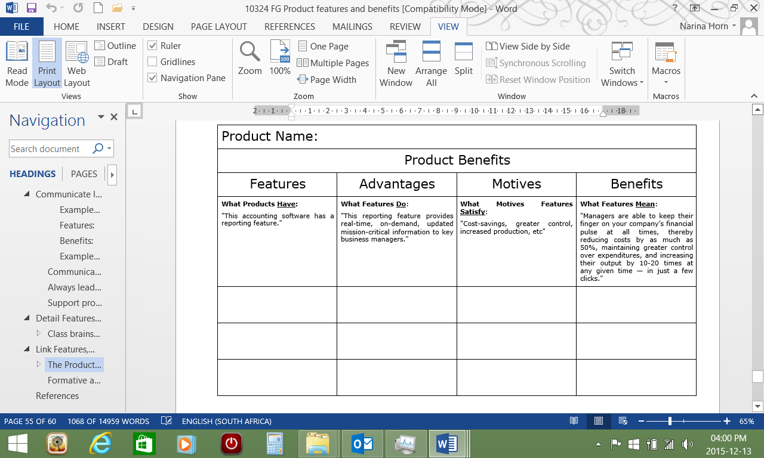

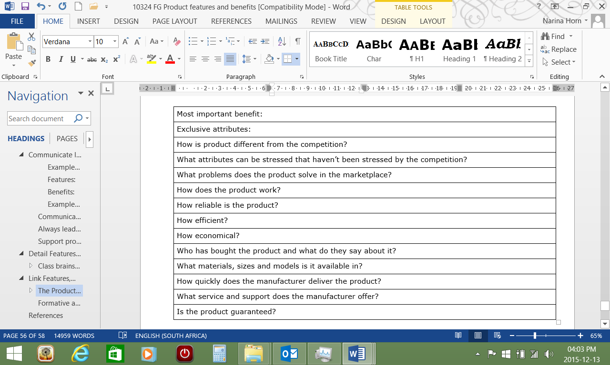

Sales Procedure SO1 AC1-3 and (EEK)
Your company will have a proposed or standard sales procedure that you have to follow when making sales. In this guide we will discuss some examples of sales procedures in order to familiarise you with sales procedures.

The seven steps of the sale
The original commonly used Seven Steps terminology is listed below using bold lettering. In recent years, more sophisticated interpretation and application of the Seven-Step selling process requires the model to be expanded and interpreted with more subtlety and flexibility, as shown here:
- preparation/planning/research/approach (using facilitative methods)
- introduction/opening/approach/establish initial credibility
- questioning/identify needs/ask how and what, etc/establish rapport and trust
- presentation/explanation/demonstration
- overcoming objections/negotiating/fine-tuning
- close/closing/agreement/commitment/confirmation
- follow-up/after-sales/fulfil/deliver/admin

1. Planning and preparation (the seven steps of the sale - 1)
Generally, the larger the prospect or organisation, the more research you should do before any sales call. You will most likely be expected to present your company's products or services, and need to be well prepared.
- Ensure you know your own product/service extremely well - especially features, advantages and benefits that will be relevant to the prospect you will be meeting
- Ascertain as far as you can the main or unique perceived organisational benefit that your product or service would give to your prospect
- Discover what current supply arrangements exist or are likely to exist for the product/service in question, and assess what the present supplier's reaction would be if their business is threatened.
- Know what your competitors are able and likely to offer, and which ones are being considered, if any
- Identify as many of the prospects decision-makers and influencers as you can, and assess as far as you can what their needs, motives and relationships within their company are
- Try to get a feel for what the organisational politics are
- What are the prospect's decision-making processes and financial parameters (e.g., departmental budgets, year-end date and so forth)
- What are your prospect's strategic issues, aims, priorities and problems, or if you can't discover these, what are they generally for the market sector in which the prospect operates?
- Prepare your opening statements and practice your sales presentation
- Prepare your presentation in the format in which you are to give it (e.g., MS PowerPoint slides for laptop, or a projected presentation) plus all materials, samples, hand-outs, brochures, etc., and always have spares - allow for more than the planned numbers as extra people often appear at the last minute .
- Prepare a checklist of questions or headings that will ensure you gather all the information you need from the meeting
- Think carefully about what you want to get from the meeting and plan accordingly
- Understand and make the most of cold-calling. Despite the tendency for some organisations to position cold calling as a lowly, de-skilled canvassing or enquiry-generation activity, cold calling increasingly enables sales people to become more strategic and significant in the sales function

2. Introduction/opening (the seven steps of the sale - 2)
- Smile - be professional, and take confidence from the fact that you are well-prepared. Thank the persons present for being there and for affording you the opportunity to present to them.
- Introduce yourself - first and last name, what your job is and the company you represent, and what the your company does (ensure this is orientated to appeal to the prospect's strategic issues)
- Set the scene - explain the purpose of your visit, and put your prospects interests first by saying, for example, "I'd like to learn about your situation and priorities in this area, and then if appropriate, to explain how we (your own company) approach these issues”. If it is clear there is common ground, agree how to move to the next stage of the presentation.
- Ask how much time your prospect has available to spare for you, and agree on a time to finish the presentation
- Ask if it's okay to take notes (it's polite to ask - also, all business information is potentially sensitive, and asking shows you realise this)
- Ask if it's okay to start by asking a few questions, or whether your prospect would prefer a quick overview of your own company first. This will depend on how well known and credible your own company is. If your company is small and unknown, you should plan to give a quick credibility-building overview in your introduction.

3. Questioning (the seven steps of the sale - 3)
- Effective questioning is a vital aspect of selling, and the points below must form part of your questioning technique.
- Empathy and listening are crucial in questioning and understanding body language is useful too
- A major purpose of questioning in the traditional selling process, is to identify the strongest need or benefit perceived by the prospect relating to the product/service being offered by the seller
- As the questioner, you need also to understand very clearly what you are seeking from the relationship - questioning should aim to identify a mutual fit - relationships work when there is a good fit from both sides
- Buyers commonly have one main need or benefit, and a number of supporting needs/benefits
- Needs and benefits may be obvious to seller and buyer, or not obvious to either, in which case questioning expertise is critical in selling, as it is an all other relationships where motives and change are involved
- Questioning must also discover how best to develop the relationship and the sale with the organisation - how the organisation decides: timings, authority levels, the people and procedures involved, competitor pressures, etc.
- Good empathic questioning also builds relationships, trust and rapport - nobody wants to buy anything from a sales person who's only interested in their own product or company - we all want to buy from somebody who gives the time and skill to interpreting and properly meeting our own personal needs
- In order to be professional in your approach, you should prepare a list of questions or headings before the discussion
- Aside from complex variations, there are two main sorts of questions: open questions and closed questions
- Broadly speaking. open questions gather information and build rapport; closed questions filter, qualify and seek commitment
- Open questions invite the other person to give long answers; closed questions invite the other person to say yes or no, or to select from (usually two) options, for example red or blue, or mornings or afternoons, etc
- Use open questions to gather information - typically for example, questions beginning with Who? What? Why? Where? When? and How?
- When training or learning the skills of using open questions, it helps to refer to the Rudyard Kipling rhyme: "I keep six honest serving men, They taught me all I knew; Their names are What and Why and When, And How and Where and Who.." This is from Just So Stories, 1902, The Elephant's Child )
- Use "Can you tell me about how..." if you are questioning a senior-level contact - generally the more senior the contact, the bigger the open questions you can ask, and the more the other person will be comfortable, and be willing to give you the information you need.
- What...? and 'how...?' are the best words to use in open questions because they provoke thinking and responses about facts and feelings in a non-threatening way
- Use 'why?' to find out reasons and motives beneath the initial answers given, but be very careful and sparing in using 'why' because the word 'why?' can be perceived as threatening to many people - it causes the other person to feel they have to defend or justify themselves, and as such will not bring out the true situation and feelings, especially in early discussions with people when trust and rapport is at a low level
- Listen carefully and empathically, maintain good eye-contact, understand, and show that you understand - especially understand what is meant and felt, not just what is said, particularly when you probe motives and personal aspects
- Interpret and reflect back to confirm you have understood what is being explained, and if relevant the feelings not expressed
- Use closed questions to qualify and confirm your interpretation - a closed question is one that can be answered with a yes or no, e.g., "Do you mean that when this type of equipment goes down then all production ceases?", or "Are you saying that if a new contract is not put in place by end-March then the existing one automatically renews for another year?"
- When you've asked a question, you must then be quiet - do not interrupt - allow the other person time and freedom to answer
- The other person (your 'prospect' in selling language) should be doing 80-99% of the talking during this stage of the sales discussion; if you are talking for a third or half of the time you are not asking the right sort of questions
- Do not be too hasty and start explaining how you can solve the problem until you have asked all your questions and gathered all the information you need (in any event you should never be seen to 'jump' onto any issue)
- At all times, try to find out the strategic issues affected or implicated by the product/service in question - these are where the ultimate decision-making and buying motives lie
- If, during the questioning you think of a new important question to ask, note it down to ensure you don’t forget it.
- When you have all the information you need, acknowledge the fact and offer your thanks, then take a few moments to think about, discuss and summarise the key issues/requirements/priorities from your prospect's organisational (and personal if applicable) perspective
- Questioning is traditionally treated by conventional sales people and conventional sales training as a process to gather information to assist the sales person's process, and this is how it is typically positioned in the old-style 'Seven Steps of the Sale. However, modern sales methodology treats questioning in a radically different way - as an essential part of a facilitative process whose purpose is to help the buyer decide
- Questioning is a fundamentally important part of selling - techniques being increasingly developed and refined far beyond early selling techniques - transferable to and from other disciplines (notably coaching, counselling, therapy, etc)

4. Presentation (the seven steps of the sale - 4)
- The sales presentation should focus on a central proposal, which should be the unique perceived benefit that the prospect gains from the product/service
- During the questioning phase, the sales person will have refined the understanding (and ideally gained agreement) as to what this is - the presentation must now focus on 'matching' the benefits of the product with the needs of the prospect, so that the prospect is entirely satisfied that the proposition
- The sales person needs an excellent understanding of the many different organisational benefits that accrue to customers, and why, from the product/service - these perceived benefits will vary according to the type of customer organisation (size, structure, market sector, strategy, general economic health, culture, etc)
- The sales presentation must demonstrate that the product/service meets the prospect's needs, priorities, constraints and motives, or the prospect will not even consider buying or moving to the next stage. This is why establishing the prospect's situation and priorities during the questioning phase is so vital
- The above point is especially important to consider when the sales person has to present on more than one occasion to different people or groups, who will each have different personal and organisational needs, and will therefore respond to different benefits (even though the central proposition and main perceived benefit remains constant)
- All sales presentations, whether impromptu (off the cuff) or the result of significant preparation, must be well structured, clear and concise, professionally delivered, and have lots of integrity - the quality and integrity of the presentation is always regarded as a direct indication as to the quality and integrity of the product/service
- It follows then that the sales person must avoid simply talking about technical features from the seller's point of view, without linking the features clearly to organisational context and benefit for the prospect - also avoid using any jargon which the prospect may not understand
- Sales presentations must always meet the expectations of the listener in terms of the level of information and relevance to the prospect's own situation, which is another reason for proper preparation - a vague or poorly prepared sales presentation sticks out like a sore thumb, and it will be disowned immediately
- When presenting to influencers, which is necessary on occasions, it is important to recognise that the sales person is effectively asking the influencers to personally endorse the proposition and the credibility of the selling organisation and the sales person, so the influencers' needs in these areas are actually part of the organisational needs of the prospect company
- The presentation must include relevant evidence of success, references from similar sectors and applications, facts and figures - all backing up the central proposition
- Business decision-makers buy when they become satisfied that the decision will either make them money, save them money or time, or both. They also need to be certain that the new product/service will be sustainable and reliable, therefore the presentation must be convincing in these areas
- Private consumer buyers ultimately buy for similar reasons, but for more personal ones as well, e.g., image, security, ego, etc., which may need to feature in these types of presentations if they form part of the main perceived benefit
- While the presentation must always focus on the main perceived benefit, it is important to show that all the other incidental requirements and constraints are met - but do not over-emphasise or attempt to 'pile high' loads of incidental benefits as this simply detracts from the central proposition
- Presentations should use the language and style of the audience - e.g., technical people need technical evidence; sales and marketing people like to see flair and competitive advantage accruing for their own sales organisation; managing directors and finance directors want clear, concise benefits to costs, profits and operating efficiency; and generally the more senior the contact, the less time you will have to make your point - no-nonsense, no frills, but plenty of relevant hard facts and evidence.
- If the sales person is required to present to a large group and in great depth, then it's extremely advisable to enlist the help of one or two suitably experienced colleagues, from the appropriate functions, e.g., technical, customer service, distribution, etc., in which case the sales person must ensure that these people are properly briefed and prepared, and the prospect notified of their attendance.
- Keep control of the presentation, but do so in a relaxed way; if you don't know the answer to a question don't waffle - say you don't know and promise to get back with an answer later, and make sure you do.
- Never belittle the competition - it undermines your credibility and integrity - don't even imply anything derogatory about the competition
- If appropriate, issue notes, minutes or a copy of your presentation
- Use props and samples and demonstrations if relevant and helpful, and make sure it all works properly
- During the presentation seek feedback, confirmation and agreement as to the relevance of what you are saying, but don't be put off if people stay quiet
- Invite questions at the end, and if your are comfortable, at the outset invite questions at any time - it depends on how confident you feel in controlling things
- Whether presenting one-on-one or to a stern group, relax and be friendly - let your personality and natural enthusiasm shine through - people buy from people who love and have faith in their products and companies

5. Overcoming objections/negotiating (the seven steps of the sale - 5)
- Decades ago it was assumed that at this stage, lots of objections could appear, because the selling process was more prescriptive, one-way, and less empathic. Successful modern selling now demands more initial understanding from the sales person, even to get as far as presenting, so the need to overcome objections is not such a prevalent feature of the selling process
- Nevertheless objections do arise, and they can often be handled constructively, which is the key
- If objections arise, the sales person should qualify each one by reflecting back to the person who raised it, to establish the precise nature of the objection - "why do you say that?”, or better still, "what makes you say that?
- It may be necessary to probe deeper to get to the real issue, by asking why to a series of answers - some objections result from misunderstandings, and some are used to veil other misgivings which the sales person needs to expose
- Lots of objections are simply a request for more information, so avoid responding by trying to re-sell the benefit - simply ask and probe instead; the best standard response is something like "I understand why that could be an issue, can I ask you to tell me more about why it is and what's important for you here?.."
- Try to avoid altogether the use of the word 'but' - it's inherently confrontational
- An old-style technique was to reflect back the objection as a re-phrased question, but in a form that the sales person is confident of being able to answer positively, for example: the prospect says he thinks it's too expensive; the sales person reflects back: "I think what you're really saying is that you have no problem with giving us the contract, but you might prefer the payments staged over three years rather than two? - well I think we could probably do something about that..."
- Another old-style technique used to be to isolate the objection (confirm that other than that sticking point everything else was fine), then to overcome the objection by drawing up a list of pro's and con's, or analysing to death all the hidden costs of not going for the deal, or re-selling the benefits even harder, and then to close powerfully. These days such a contrived approach to objection handling is likely to insult the prospect and blow the sales person's credibility
- The 'feel-felt-found' technique was another popular tactic in overcoming objections. This is a response built around the three 'feel felt found' elements: "I understand how you feel/why you feel that...//Other customers have felt just the same/that...//But (or 'And') when... they have found that..." The method uses empathy in stage one, neutrality and group reference (shifting the issue away from personal confrontation) in stage two, and then counters the objection and reinforces the benefits using majority evidence in stage three, in the hope of persuading the buyer that he/she is isolated and missing out if deciding not to buy
- It is important to flush out all of the objections, and in so doing, the sales person is effectively isolating them as the only reasons why the prospect should not proceed, but then the more modern approach is to work with the prospect in first understanding what lies beneath each objection, and then working with the prospect to shape the proposition so that it fits more acceptably with what is required..
- Avoid head-to-head arguments at all costs - even if you win them you'll destroy the relationship and you'll go no further. Instead, the sales person should enable a constructive discussion so that he and the prospect are both working at the problem together, provided the basic proposition is sound most objections are usually overcome by both the seller and the buyer adjusting their positions slightly. For larger prospects and contracts, this process can go on for weeks, which is why this is often more in the negotiating arena than objection handling
- You've handled all the objections when you've covered everything that you've noted down - it's therefore important to keep notes and show that you're doing it
- By this stage you may have seen some signs that the prospect is clearly visualising or imagining the sale proceeding, or even talking in terms of your working together as supplier and customer. This is sometimes called buying warmth. Certain questions and comments from prospects are described as buying signals, because they indicate that the prospect may be visualising buying, or having the product/service. In the old days, sales people were taught to respond to early buying signals with a 'trial close', but this is widely perceived as clumsy and insulting nowadays. Instead, respond to early buying signals (ie those received before you've completed the presentation to the prospect's satisfaction, and answered all possible queries) by asking why the question is important, and then by answering as helpfully as possible

6. Close/closing/agreement (the seven steps of the sale - 6)
- In modern selling, even using the traditional Seven Steps process, every sales person's aim should be to prepare and conduct the selling process so well that there are few if any objections, and no need for a close
- The best close these days is something like "Are you happy that we've covered everything and would you like to go ahead?", or simply "Would you like to go ahead?"
- In many cases, if the sales person conducts the sale properly, the prospect will close the deal himself, and this should be the another aim for the sales person - it's civilised, respectful, and actually implies and requires a high level of sales professionalism
- The manner in which a sale is concluded depends on the style of the decision-maker - watch out for the signs: no-nonsense high-achievers are likely to decide very quickly and may be a little irritated if you leave matters hanging after they've indicated they're happy. Cautious technical people will want every detail covered and may need time to think, so don't push them, but do stay in touch and make sure they have all the information they need Very friendly types may actually say yes before they're ready, in which case you need to ensure that everything is suitably covered so nothing can rebound later
For the record, here are some closes from the bad old days - the traditional golden rule was always to shut up after asking a closing question, even if the silence became embarrassingly long - (a who-talks-first-loses kind of thing). Use them at your peril!
- The pen close: "Do you want to use your pen or mine?" (while producing the contract and pen)
- The alternative close: for example - "Would you like it delivered next Tuesday or next Friday?", or "We can do the T50 model in silver, and we have a T52 in white - which one would you prefer?"
- The challenge close: "I know most men wouldn't be able to buy something of this value without consulting their wives - do you need to get your wife's permission on this?." or "Most business people in your position need to refer this kind of decision to their boss, do you need to refer it?"
- The ego close: "We generally find that only the people who appreciate and are prepared to pay for the best quality go for this service - I don't know how you feel about it?..."
- The negative close: "I'm sorry but due to the holidays we can't deliver in the three weeks after the 15th, so we can only do it next week, is that okay?"
- The guilt close: "Over three years it might seem a lot of money, but we find that most responsible people decide they simply have no choice but to go for it when it's less than a rand a day to protect your.../safeguard your..../improve your... (whatever)."
- The sympathy close: "I know you have some reservations that we can't overcome right now, but I've got to admit that I'm pretty desperate for this sale - my manager says he'll sack me if I don't get an order this week, and you're my last chance - I'd be ever so grateful if you'd go ahead - and I promise you we'd be able to sort out the extra features once I speak to our production people..." (How could anyone live with themselves using that one?)
- The puppy dog close/puppy dog sale: "Let me leave it with you and you see how you get on with it..."
- The last ditch close: (sales person packs case and goes to leave, but stops at the door) "Just one last thing - would you tell me where I went wrong - you see I just know this is right for you, and I feel almost guilty that I've not sold it to you properly, as if I've let you down....."
- The pro's and con's list: "I can appreciate this is a tough decision - what normally works is to write down a list of all the pro's and con's - two separate columns - and then we can both see clearly if overall it's the right thing to do..."
- The elimination close: "I can see I've not explained this properly - can we take a moment to go through all the benefits and see which one is holding us back from proceeding?" (At which the sales person lists all the benefits - the positives, and runs through each one to confirm it's not that one which is causing the problem, crossing a line through each as he goes. When he crosses the last one out he can claim that there really seems to be no reason for not going ahead...)

7. Follow-up/fulfilment/delivery/admin (the seven steps of the sale - 7)
- After-sales follow-up depends on the type of product and service, but generally for every sale the sales person must carry out a number of important processes:
- All relevant paperwork must be completed and copies provided to the customer - paperwork will cover the processing of the order, the confirmation of the order and its details to the customer, possibly the completion of installation and delivery specification and instructions.
- Sales reporting by the sales person is also necessary, generally on a pro-forma or computer screen, typically detailing the order value, product type and quantity, and details about the customer such as industrial sector - each sales organisation stipulates the sales person's reporting requirements, and often these are linked to sales commissions and bonuses, etc.
- The sales person should also make follow-up contact with the customer - as often as necessary - to confirm that the customer is happy with the way the order is progressing. This helps reduce possible confusion and misunderstood expectations, which are a big cause of customer dissatisfaction, and can lead to order cancellation if left to fester unresolved
- Customer follow-up, and problem resolution must always be the responsibility of the sales person, who should consider themselves the 'guardian' of that customer, even if a well-organised customer service exists for general after-sales care
- Customers rightly hold sales people responsible for what happens after the sale is made, and good conscientious follow-ups will usually be rewarded with referrals to other customers - this is also helpful for networking
- Follow-up is an important indicator of integrity; when a sales person makes a sale he is personally endorsing the product and the company, so ensuring that value and satisfaction are fulfilled is an integral part of the modern sales function

Four steps

Meet and Greet
This is the first contact with the customer and is therefore very, very important. Humans form an opinion of another person within something like 30 seconds.
When the customer parks on the lot, try to meet them either at the car or the door, depending on the procedure in your organisation.
When you meet them in the parking lot, just say hello while they are getting out of the car. Then greet them with the official company greeting: “ Good Morning and welcome to So and So Motors. My name is Andy and you are?” let them introduce themselves, shake hands, memorise their names and thank them for coming to this store.
The first thing you will need to do is to meet a customer on the lot. Try and be there when they pull in as this will keep your competitor salespeople off your up (opportunity).
Make sure that you smile and that your appearance is neat and professional.

Qualifying
Once you have welcomed everyone and been introduced to them all, it is time to find out what car they wish to purchase. This is done by asking questions. Once you have asked a question, keep quiet and give the customer time to think about the answer and then listen to their answer.
You don’t have to keep on talking, the average customer would much rather talk about himself than listen to you.

Suggested questions
- Which vehicle are you interested in?
- Did you see our advertisement?
Your dealership may have a specific script you are expected to follow, make sure that you follow the workplace procedures.
It is also important that you are up to date on advertisements, special offers and new vehicles.
The purpose of this stage of the sales process is for you to gather knowledge about the customer. Do not ignore anyone in the group if you are dealing with a group, and try to find out who will answer the questions and make the decisions. This stage must not last too long

Choosing a Vehicle
This stage involves the choice of vehicle. Make sure that you suggest a car that your client can afford. Once you have shown a more expensive car, which would have more features and benefits, it would be difficult to get the customer to buy a cheaper car that he can actually afford. With the law in South Africa, it could lead to unwanted consequences such as having to take the car back, etc.
If the customer does not know what they want to spend or they will not tell you start showing them the cheapest cars you have until you find something they like. If they pick out the vehicle they cannot blame you for the payment being higher then they wanted to pay.

15 Step Car Sales Technique
The purposes of following certain steps in the sales process
The main purpose for following the steps of the sale: to control your customer and sell a car!

Step 1: Meet and Greet
This is covered earlier in this section

Step 2: Find out if someone else has helped them previously
If the customer has been dealing with someone else, the ethical thing to do is to direct them to the other sales person. So, ask them: “Is this your first time up here or have you been here before?"
If it is the first time, it is your customer and you carry on to the next step

Step 3: Find out what the buyer needs
The best way to do this is by asking either/or questions
Whatever you do, do not ask them about their credit score, if they are serious about doing business today, etc. You have to be more subtle than this.
- Are they shopping for themselves or for someone else
- Do they want a car, an LDV or an SUV
- Are they interested in a 2-door or 4-door
- What colour are they looking at
- What extras are they interested in, etc.

Step 4: Find out what their buying motive is
There are 6 basic reasons why people buy cars, and these reasons are represented by the acronym S.P.A.C.E.D.
- Safety/Security,
- Performance,
- Appearance,
- Comfort/Convenience,
- Economy and
- Dependability.
To find out a client’s buying motive, ask him: “Why did you choose this car?”

Step 5: Test Drive
Of course, you always have to drive with them!!!
Depending on the procedure in your organisation, you can let them drive first while you get to know them, or you can drive first to show them how the car works.
Now is the time to ask them questions leading up to the sale. Link these questions to their most important buying motive: S.P.A.C.E.D.
“This car is very safe, isn’t it?”
“This car’s performance is very good, isn’t it?”
Experts say you have to add the phrase “isn’t it?” at the end of your sentence. When the customer says “Yes”, they are one ore step closer to the sale

Step 6: Trial Close at End of Test Drive
At the end of the test drive it is time for a trial close –find out if the customer might buy this car.
Agree that this is the perfect car for them and let them park the car in the “sold” space so that someone else cannot buy their car.
If they do not agree that they are ready to buy, you have to take the customer inside to negotiate further.

Step 7: Bring them Inside
Even if the customer is ready to buy, make sure that you take them inside to complete the paperwork

Step 8: Attempt Another Trial Close
At this point you will start the paperwork if the customer has agreed to purchase the car. If not, you have to handle their objections. See Step 10

Step 9: Confirm the amounts involved
While you are completing forms, you also have to confirm the amounts that will be involved: the purchase amount of the car, the add-ons and extras and the interest rates involved (if you have the interest rates available)

Step 10: Overcome Objections (if Needed)
This is covered in a later section

Step 11: Complete the required forms
Depending on the procedure in your company you or the customer will complete the credit application form
Get copies of the customer’s driver’s licence
Discuss insurance options with the client

Step 12: Explain the next steps to the client
Explain that you will now arrange financing for the vehicle and that you will be in touch with them, or if it is possible get approval for the financing immediately, depending on the procedure in your organisation

Step 13: Before the delivery
Make sure the car is cleaned, has fuel (the amount of fuel will depend on your organisation), the extras have been added and that the car is ready for delivery to the customer.

Step 15: Follow up
Follow up with this customer. They will buy more cars in the future and they will have friends/family members who will also buy.
The above was adapted from the following website:
http://carsalesassistant.com/CarSalesTechniques/Steps-Of-The-Sale.html

Buying Signals

Customer signals
When customers come into your sights, whether it is a retail store, at an exhibition or in any other environment, they will be sending you signals.
The signals that they send will include:
- I am just wandering around with no real interest in products and intention to buy.
- I am interested in this product, but am not currently anxious to buy.
- I am very interested in this and might well buy it if you can answer a few questions.
- I want to buy this, now!
Buying signals could be verbal or non-verbal or a combination of both. They are called buying signals because the seller is “signalling” that he is ready to buy. The customer will not usually come right out and say that he is ready to buy the car, this is why you have to be aware of buying signals. Some of these signals include enthusiasm or excitement of your product.
When the customer starts asking questions, it is a sign that he is interested and could be persuaded to buy. Someone who is not interested will not really ask any questions at all. When a customer, for example, asks: “How long will delivery take?” you can be sure this is a strong buying signal. It is time to close the sale.
Other strong buying signals include when the customer asks you to repeat something or asks questions to get more information about the car.
Answer his questions and then add to his enthusiasm by explaining how his life will improve by owning this car.
Any time a prospect asks you questions during your sales presentation, it's an encouraging sign. After all, it's a prospect wasn't interested at all he wouldn't bother asking you questions. But certain questions send a particularly strong statement of interest. These are generally questions that indicate the prospect is imagining himself owning the product.
For example, a prospect might ask a question such as, “Who will be responsible for supporting the product?” or “How long does delivery take?” These are extremely strong buying signals and should indicate to you that the customer is really interested.
Once you've answered the prospect's question, you can develop his interest further by painting a picture of what his life will be like once he owns the product.

Verbal buying signals
If they say: “Could I see that again?”
If they say: “How soon can I get one?”
If they say: “How much would it cost for a hundred of these?”
Buying signals often come in the form of simple mundane questions like:
- How much is that one?
- Do you have one in blue?
- Do you deliver?
- How soon can you deliver?
- How long does the job take?
- Do you offer finance?
- Is there a backup service?
- Does that price include vat?
- How long is it guaranteed for?
- Is that your best price?
- Do you need a deposit?
Your customer might turn to a friend or family member and ask for their approval:
- What d'ya' think?
- Would that match the carpet?
- Will we get it in the car?
- Your credit card or mine?
These simple questions are all typical buying signals, which reveal that the customer is seriously considering ownership of the product:
- ‘Will it go in the car?’ Why would they ask that sort of question if they weren’t planning to take the product away with them?
- ‘Is that your best price?’

Nonverbal buying signals
- If they: Lean forward in their chair.
- If they: Start writing or making calculations.
- If they: Touch their face, feel for their wallet or start looking for their cheque book, you are getting buying signals from your customers’ body language.
If your customers smile a lot you’re making a good impression
On the other hand, if you see too much of a person’s back, i.e. no eye contact, it probably means he or she has seen too much of your face
People who are interested in a product tend to start handling it as if they already own it. Fondling an item indicates a desire for ownership.
On the other hand, if a customer discards an item that would suggest that they are not interested in the product.
Other signs include:
- A customer deep in thought
- Someone who keeps on coming back to the same item
Be ready for questions like,
- "Do you deliver?" Or, "Does that price include vat?" Few people discuss VAT, until they have to pay it - otherwise it’s just small talk, because, like the weather, there’s not much we can do about it.
- “Is there a delivery charge?” How would that concern someone who isn’t going to have to pay such a charge? “How long does the offer stand?” Who cares, if they’re not interested in the offer? Yet, these are all buying signals.
- The customer might seem preoccupied, and repeat a question like, "How much was that one again?" This often indicates that the customer is ready to buy, and at the stage of choosing a specific model or type. Dig a bit deeper, i.e. ask some more questions; you might be able to advise them.
- "We're going on holiday in a fortnight. Can we have it installed before we go away?" This is the ultimate buying signal. Your customer has given you a leg up here; it's an opportunity for you to get the order form out and start to close the sale, because now you can say, "When would you like it delivered? I can put special delivery instructions onto the order form." Now you’re filling out the order form, and your customer has saved you the trouble of asking for the sale.

When they are not ready to buy
When a customer is not ready to buy, it does not mean that they will not buy, but it does mean that you will need a different approach. Do remember also that if there are many customers around, spending a lot of effort selling to one customer may mean that you miss out on a lot of other easier sales.
Avoiding eye contact with you
When you look at them and they immediately look away, they probably do not need assistance right at this moment. Do watch what they are doing, because they may need some help soon.
If they are handling a limited range of products, spending time looking at things, then it may be a good idea to stand nearby, relaxed and ready to help (not anxious and ready to pounce). When they look at you with a longer glance, move toward them. If they keep looking, keep moving in and start the sale.
Making 'not now' excuses
If they say 'just looking' or otherwise indicate that they don't need help, then make an encouraging remark to keep them looking and back off. Still keep an eye on them to see if their demeanor changes.
Casual handling of the product
If they are casually picking up different products and dropping them back, perhaps not tidily, it can be a big nuisance for you as you tidy up after them (when they have left) but this may well be a symbol of a bored browser. As ever, keep an eye on them so you can move in when they change how they are behaving.
Looking at many different products
If they are wandering around looking at almost random products, spending a similar short time on each one, then they may again be a relatively bored browser.
Moving around quickly
When they are moving quite quickly around the place, they may be scanning for something or may be wandering. If they slow down, watch more carefully and move in when they are showing more signs of interest.

When they are ready to buy
When the person is ready to buy, or at least they are showing some interest, then you should also be ready to pick them up and move them towards the final close.
Spending time looking at one product type
When they are looking at one type of product, and especially if you have a broad range from which they are browsing only a small category, then they may well be interested in buying. Perhaps they need advice, so ask if you can help them decide.
The longer a person looks at one product type, the more likely they are to buy it. They are investing their time, which is a sure sign of interest.
Looking around for somebody to help them
If you see them looking around, catch their gaze, and perhaps raise your eyebrows a little to signal that you are ready to help. If they sustain the glance or raise their eyebrows too, move in to sell.
This is particularly significant if they are holding the product or have just spend time looking at a limited product range.
Asking questions about the detail
If, when you offer help, they get into more detail about the product, then they are likely to be becoming more interested.
If they ask about the functionality of the product, they may well have a checklist of things they are seeking, so ask for details of what they are seeking. You can also ask more about how they will use the product, from which you can advise on the best buy for them.

Asking about price
This is a good buying signal. You can tell them the price or you can ask how much they are looking to spend today. If they tell you, then you can help them find the best value for the money they have to spend.
Using possession language
When they pick up the product, they are getting a sense of owning it. This continues when they talk about how they will use the product -- which is a good reason for encourage this talk. Look for 'I' language. Get them to use it. Ask how they will use it. You can even talk about it as if they already own it, although be careful of being unsubtle and pushy.
Asking another person’s opinion
When they ask another person what they think about the product, they are likely thinking about buying the product and are seeking confirmation.
You might thus find yourself selling it to the second person also. Think about this when you are making the initial sale -- include whoever else is there in the sales talking, though do watch for whether the main seller wants to be the main focus or appreciates others being included.
Body state changes
Any transition in non-verbal communication will typically signal a change in mental state that may well indicate readiness to buy. If they suddenly relax after asking questions or discussing the product, this may well signal that they have changed mental state. Other signals includes changes in body position, gesture, skin tone, style of talk and so on.
Touching the money
If they touch their wallet or purse and especially if they get out cash or credit card, this is a very strong signal for you. Get to them and ask if you can help. If they say they want to buy, just take their money (and do beware of 'unselling' the product by your over-zealous and non-needed sales patter).
http://changingminds.org/disciplines/sales/articles/buying_signals.htm

SECTION 3: HANDLE OBJECTIONS

Specific outcome 4
Handle and deal with customer objections and concerns

Assessment criteria
- The method of clarifying and addressing concerns and objections of customers are described in terms of organisational policies
- A proposal to address customer objections and concerns is formulated in terms of company policies and procedures
- The procedures to deal with unresolved objections and concerns are described in terms of company policy

Essential Embedded Knowledge
- Presentation skills related to the retail industry.

CCFO
Collecting: Collect, analyse, organise and critically evaluate information relevant to conducting sales in the automotive vehicles.

Introduction
When you ask for the sale (close the sale), it often happens that the customer responds negatively, for example by giving excuses. The salesperson should respond to this negativity by handling the objections.
Note Objections are usually a buying signal, although not a powerful one.
An objection can also mean that the customer is interested in your product or service, but has concerns about aspects of the sale. Objections such as: “I cannot afford this” or “I do not like the colour” are an indication that the customer is interested but not yet ready to buy.
If you handle the objection, you will usually be able to close the deal.
This means that objections are a good sign, not a problem – if you handle them right, your efforts will lead to a sale.

Objection-Handling Process SO4 AC3
We will start off with general guidelines and steps about the objection-handling process. There are 5 basic steps involved

1. Listen
Close your mouth and open your ears so that you can identify the objection – you have two ears and one mouth, probably so that you listen more than you speak
Do not interrupt the client, this is just rude
While you are listening, show interest by looking at the client and nodding – be sure to make eye contact

2. Question
Once the customer has stopped speaking, it is your turn. Now you have to ask questions in order to gather more information.
Also note the client’s body language – non-verbal signs - that will also give you hints about how the customer is feeling and what he is thinking

3. Think
You now know that your client has objections and you know what the objections are. Think about the best technique to handle these objections. We will discuss several techniques later in this section.

4. Handle
Handle the objection using the technique you have chosen

5. Check
Find out if you have handled the objection by asking them questions. For example, ask if he has any more concerns. If the objections have been handled, you can close the sale

Techniques for handling objections
There are many techniques for handling objection. The list given below does not include all the techniques.
We will discuss only some of these techniques and you will have to research the others yourself so that you know how they work.

Objection-handling techniques and methods
- Boomerang: Bouncing back what they give you.
- Conditional Close: Make closure a condition for resolving their objection.
- Curiosity: Don't be sad, be curious.
- Deflection: Avoid responding to objection, just letting it pass.
- Fallback: Step back and remove reason to object.
- Fear, Uncertainty and Doubt (FUD): A negative but effective ploy.
- Feel, felt, found: A classic way of moving them.
- Humor: Respond with humor rather than frustration.
- Justification: Say how reasonable the objection is.
- LAARC: Listen, Acknowledge, Assess, Respond, Confirm.
- LAIR: Listen, Acknowledge, Identify objection, Reverse it.
- Objection Writing: Write down and cross out objections.
- Pre-empting: Handle them before they happen.
- Pushback: Object to their objection.
- Reframing: Change their cognitive frame.
- Renaming: Change the words to change the meaning.
- Reprioritize: So ones you can't handle are lower.
- Writing: Write down objections then cross them off as you handle them.
The following is adapted from:
http://changingminds.org/disciplines/sales/objection/objection_handling.htm

Boomerang method
Use the customer’s own words like a boomerang to prove him wrong. The argument goes in a circle, starting with the customer’s objection and ending with your argument proving him wrong, as per the examples below:
Yes, it is expensive, but I don't think you would want to buy your wife a cheap present / unsafe car .
Because you are using their own words, you are actually saying that the customer is right, then you attach what you want to say. This means that you are also right

Conditional Close
With this close you offer to solve the customer’s problem for him by saying: “'If I...will you”. You provide a solution to the objection by attaching a condition to it: “If I can arrange finance for the car will you buy it?”
It is important to always start with : 'If I...will you...' and not 'Will you...if I...'.
Remember that we think must faster than we talk and if you start with 'Will you...’, the customer may start thinking about objections before you reach the benefit.
You can also use this approach to make any trade - for example if you want them to watch a promotional video, offer a cup of coffee.
It is important to phrase it as
You say you want a red one. If I can phone up and get you one, will you take it today?
If we can figure out the finance for you, will you choose this one?
If I get you a cup of coffee, would you like to sit down and look through the brochure?

Curiosity
When the customer objects, act curious but do not just ask 'Why??', you also have to show that you are interested in why they do not want to buy right now, for example: 'how interesting - I wonder why'.
This gives you an opportunity to find out why the customer is not interested, even if he does leave without buying
I know you don't want to buy this, but before you go, could you just let me know what your reason was?
I was just wondering what led to your decision not to buy this today.
Most people really go for this one. I am a little curious as to how you decided otherwise.
Did I not explain it clearly enough?
Was I a bit too enthusiastic? Sorry, but I just love these.
When you are non-threatening and not in 'closing mode' they may well relent and give you the information you need.

Fallback
When using this technique, you stop pushing for the sale, take a step back and act as if you are not in a hurry. The customer expects you to push back and he may have more arguments why he does not want to buy now. When you do not resist, but rather validate his objection or agree with him, you will catch him off-guard and this could give you an opening to close again. Give him nothing to object against, then watch what he does. If the customer says something encouraging that shows that he is still interested, start feeling your way forward again.
Customer: Well I'm not really sure.
You: Of course, we've plenty of time here and if you're not yet sure that's just fine.
Customer: I can't afford that.
You: Which is a good point and I won't sell you anything you can't afford. Can I ask you more about what you are seeking?
Customer: I'm not buying from you.
You: And that's just fine. I've got another appointment now anyway.

Fear, Uncertainty and Doubt (FUD)
FUD stands for fear, uncertainty and doubt. This method is used to prevent the customer from buying competitors’ products. You give him information that triggers fear and uncertainty, or sows seeds of doubt. For example, you suggest that
- competing products are problematic.
- competitors have operational problems.
- promised competing products will not be delivered as suggested.
You can even use FUD on your own products, e.g.:
- Support for old products will be stopped.
- Prices will be going up.
- Products are so desirable you will be soon running out of stock.
- That 'preferred customer' status may be withdrawn.
When a competitor launches a new product, a marketing manager announces that a better product will be released later in the year, even though release dates are very uncertain. The uncertainty caused is enough to cause many customers to wait.
A sales person, when told that a customer is considering a competitor solution, produces a recent news article that indicates that the competitor firm is likely to be a target for acquisition.
Buyers often make decisions using a checklist which can be mental or written down. They will start with the functions they want, then look at costs. As buyers we usually do not think about risks and uncertainties about the product, e.g. failure, late deliveries, waiting time for specific colours and so on.
When you mention risks, it creates fear and other negative emotions and could lead to a change of mind.

LAARC
- Listen
- Acknowledge
- Assess
- Respond
- Confirm
- Listen

Listen
Listen to the customer. This is the only way you will be able to offer him what he actually wants and not what you think he wants.
Do not interrupt, wait patiently until the customer has finished speaking

Acknowledge
The next step is to acknowledge the customer’s point of view – the validity of his objection. If you do not do this the customer may take your response as an insult.

Assess
When you assess the situation, you will usually ask various questions in order to gather more information. People hardly ever give the true reason the first time they object. You have to delve deeper in order to get to the actual objection.

Respond
Now you should have an accurate idea of the objection and this is the time to respond, using one of the other closing techniques.

Confirm
Finally, check with the other person that they have understood your response and that it addresses their concerns.
If the other person still has the objection, repeat the loop. See if you have listened well enough in the first place. Check that you have assessed their situation correctly. Ensure that the response fully and adequately addresses their concerns.

Objection Writing
When the customer objects, find out if he has more objections then start writing them down one by one as the customer mentions them. This is called tipping the bucket: when you ask for more objections in order to get all the objections the have been thinking about
Write all the objections on a clean sheet of paper, then show it to the customer. Confirm that if you can address the objections, there would not be any reason for the customer not to buy.
Then handle each objection, crossing them out as you work down the list. Ask the customer: 'So, we have addressed this. Can I cross this out now?'
When you write objections on a sheet of paper, you are moving the objectives from the customer’s mind to the sheet of paper where you can cross them out. This eliminates the objection, also in the customer’s mind.

Company Policies And Procedures AC1-2 (EEK Sales Presentations)
We have discussed certain specific methods of handling objections. This was an introduction only and there are many more ways of dealing with objections than those listed here.
Your company will probably have a specific procedure laid down that they wat you to follow. This will include specific methods of sales presentations for corporate clients and for different demographics. The sales techniques you will use will be different for different types of customers:
- Corporate customers
- Men and women
- Older and younger people
You will have to follow these procedures. If you have a better suggestion, follow the procedure in your organisation to suggest changes to the procedures.

Successful sales presentations
The following is based on content in the following:
ABCs of Relationship Selling (Mcgraw-Hill/Irwin Series in Marketing) 9th Edition
by Charles M. Futrell (Author)
We will discuss several sales presentation methods. You have to make sure that you select the method using the following criteria, as well as the procedure in your organisation:
- Prior knowledge of the customer
- Sales call objective
- Customer benefit plan

Presentation Strategy
As a sales person you will face more than one sales situation in your career:
- Salesperson to buyer – just you and the customer
- Salesperson to buyer group – for example you and the following staff members at the customer: financial manager, operations manager, CEO
- Sales team to buyer group – you and some more members of the sales team including the manager to a group of people at the customer
- Conference selling – this can be at a conference where you network or where the purpose of the conference is to sell a product or a range of products
- Seminar selling – this takes place at a seminar

Sales presentation methods
There are four main sales presentation methods:
- Memorized
- Formula
- Need-satisfaction
- Problem-solution
The basic difference between the four methods is the percentage of the conversation controlled by the salesperson.

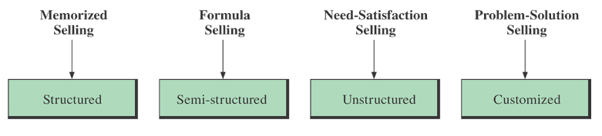

The Memorized Sales Presentation
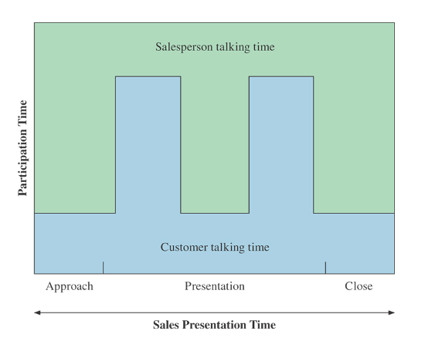

This presentation is based on one of the following two assumptions:
- The prospect’s needs may be stimulated by direct exposure to the product through the sales presentation.
- The prospect’s needs have already been stimulated because the prospect has made the effort to seek out the product.

When to use the memorised method
It is effective when:
- Selling time is short, as in door-to-door or telephone selling
- The product type is non-technical – such as books, cooking utensils, or cosmetics
This method ensures that
- the salesperson gives a well-planned presentation
- all of the company’s salespeople give the same information
It also helps the inexperienced salesperson and boosts his confidence.
Why not to choose the memorized (canned) sales presentation method
There are times when this is not the best sales presentation method, because it:
- Presents FABs that may not be important to the buyer
- Allows for little prospect participation
- Is impractical to use when selling technical products that require prospect input and discussion
- Requires the salesperson to proceed quickly through the sales presentation to the close, resulting in several closes or requests for the order, which may be interpreted by the prospect as high pressure selling
- Interruptions – salesperson may get off-track; forget
Example: Dyno Electric Cart Memorized Presentation
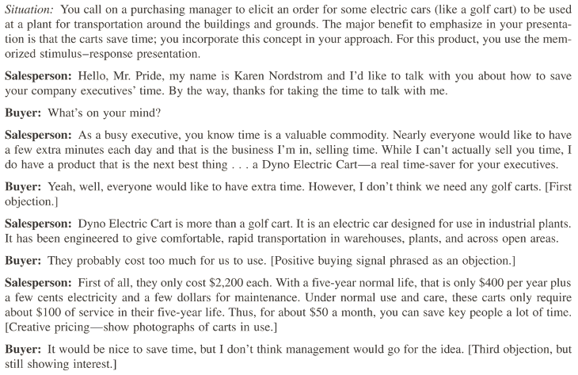
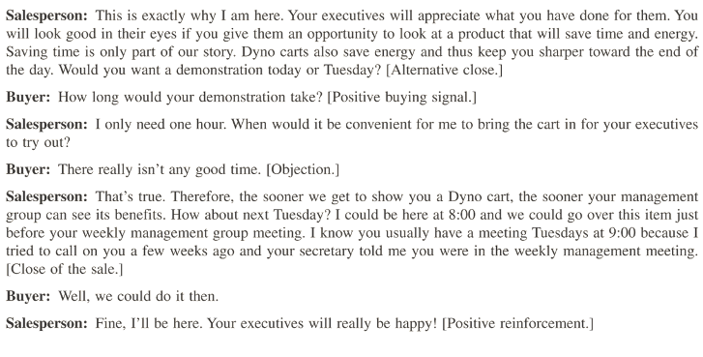

The Formula Sales Presentation
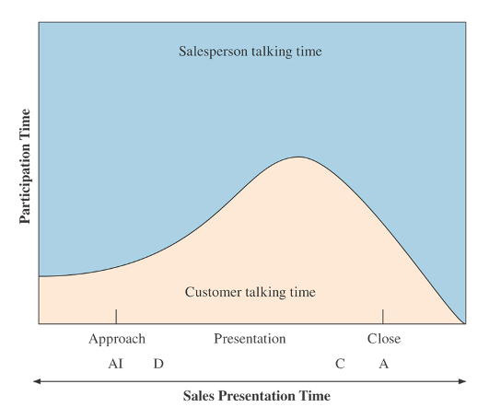

- Often referred to as the persuasive selling presentation
- Salesperson follows a less structured, general outline allowing more flexibility and less direction
- AIDA: Attention, Interest, Desire, Action
- Straight Rebuy situations
Following is the SmithKline Beecham products example: “The 10-step Productive Retail Sales Call”
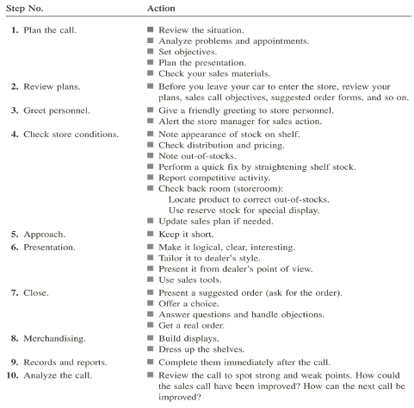

Here are the steps for the formula sales presentation
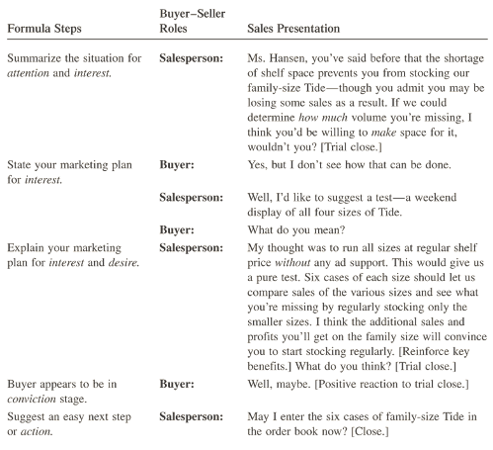

You will choose the Formula Sales Presentation Method when you:
- Are contacting similar prospects in similar situations
- Know something about the prospect
- Have called on the prospect in the past
- Want to ensure all information is presented logically
- Want to have reasonable amount of buyer-seller interaction
This method makes it possible for you to smoothly handle anticipated questions and objections
Examples of product types that work well with this method are:
- Consumer goods
- Pharmaceutical goods

Do not choose this method when you:
- Do not know the prospect’s needs
- See a need for the prospect to talk more
    - Have a complex selling situation such as: selling a technical product or selling to a group

The Need-Satisfaction Presentation
- This is the most challenging and creative form of selling
- Interactive sales presentation
Phases
- Need-development Phase
You allow and encourage the customer to discuss his needs
- Need-awareness Phase
You take control of the conversation by restating the prospect’s needs to clarify the situation
- Need-fulfillment Phase
You show the customer how your product will satisfy these mutually agreed-upon needs

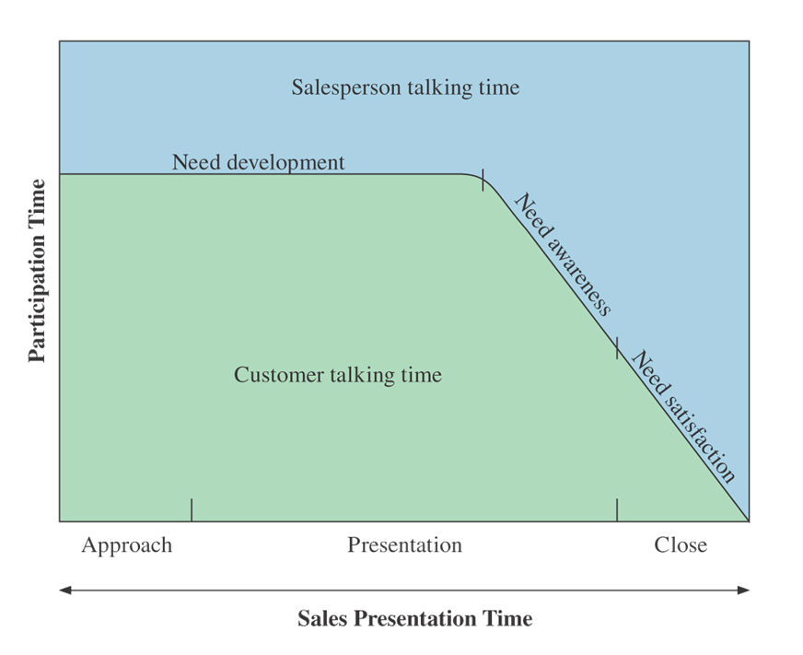
Example
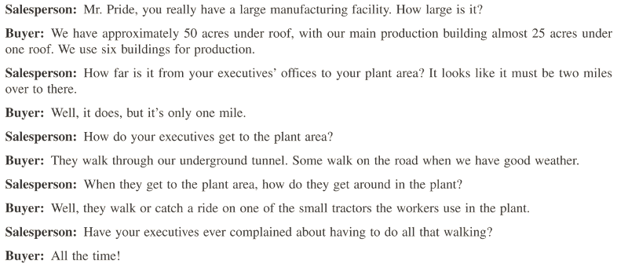
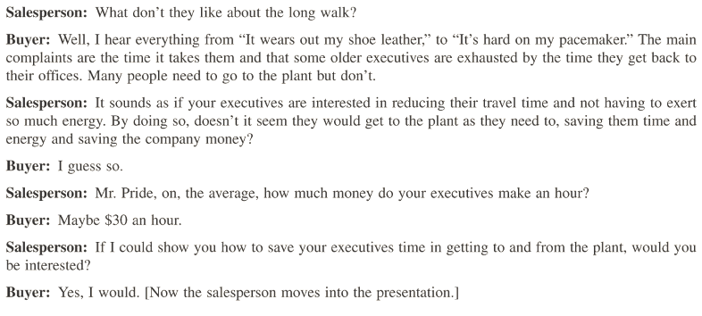
You will choose this method when you:
- Need a flexible, interactive sales presentation
- Need to uncover needs by asking questions
- Need the prospect to talk about his needs
The first time that you call on a prospective customer, this is the best method to use. Once you have made contact with the customer and you know what he needs, you will select a different method, e.g. the formula sales presentation
Examples of product types that work well with this method are:
- Financial services
- Systems
- High priced goods/services such as vehicles, real estate, computer systems, industrial equipment
Do not use this method when you:
- Need more control over the conversation
- Feel you should not ask too many questions
- Are new to the sales profession

The Problem-Solution Presentation
This is a flexible and customized approach that includes an in-depth study of a prospective customer’s needs and it may take several visits to the customer so that you can develop a detailed analysis.
This presentation usually consists of six steps
Step 1 - Convincing the prospect to allow the salesperson to conduct the analysis
Step 2 - Making the actual analysis
Step 3 - Agreeing on the problems and determining that the buyer wants to solve the problem
Step 4 - Preparing the proposal for a solution to the prospect’s needs
Step 5 - Preparing the sales presentation based on the analysis and proposal
Step 6 - Making the sales presentation

Choose the problem-solution sales presentation method when you:
- Are selling highly complex or technical products
- Are required to make several sales calls to develop a detailed in-depth analysis of a prospect’s needs
- Need a flexible, customized presentation based on findings

What is the best presentation method?
Use the following guidelines to help you select the best method
- Memorized – short time simple product
- Formula – repeat purchases; when you know prospect’s needs
- Need-Satisfaction – need to gather information from prospect first
- Problem-Solution – high-cost tech products; several calls and business proposal
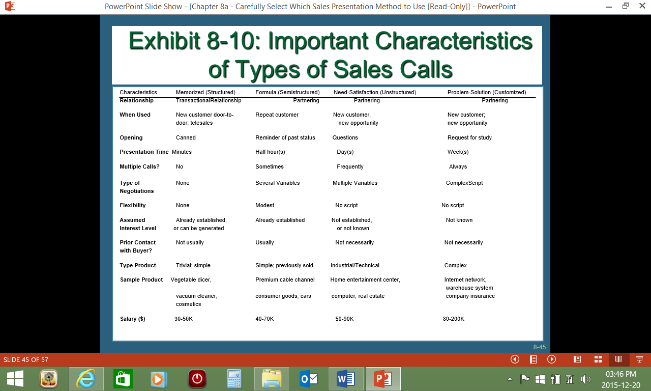

Group Presentations
This usually applies to a corporate customer where either you or your team presents the proposal to a group of decision makers.
The flexibility of the presentation depends on size:
- The larger the group, the more structured your presentation
- You can structure the presentation and provide a question-and-answer period at the end or during the presentation
- Give a proper introduction
- State your name, company, and proposal
- Establish Credibility
- Give a brief history of your company
- Provide an Account List
- Have copies of an account list available
- State your Competitive Advantages
- Tell the group where your company stands relative to the competition
- Give Quality Assurances and Qualifications
- State Guarantees in the beginning
- Cater to the Groups Behavioral Style
- Determine the overall dominant style in order to hold their attention
- Get people involved
- The proposal
- No prices
- Summarize Benefits

First select the presentation method, then the approach
- Know which method to use before developing the presentation
- Plan the presentation
- Select the approach/opening

The Parallel Dimensions of Selling

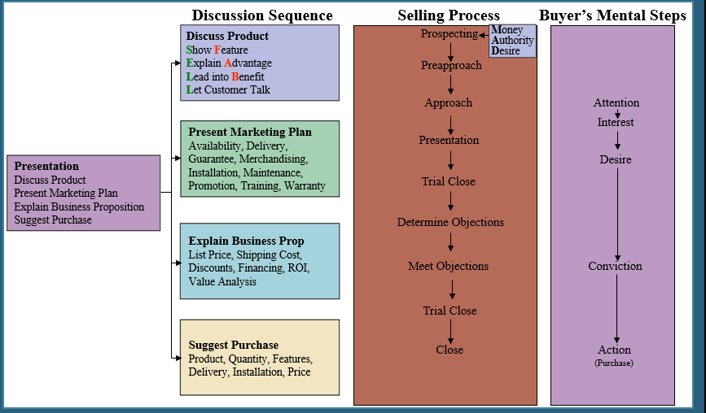

It’s important to know that these parallel dimensions interact
- Discussion sequence
- Selling process
- Buyer’s mental steps

- You must master the art of giving a good sales presentation
- The sales presentation method selected should be based on prior knowledge of the customer, your sales call objective, and your customer benefit plan
- Show that you have a right to present your product because it has key benefits for the prospect
- Many different presentation methods are available
- There is no one best method; each one must be tailored to meet the particular characteristics of a specific selling situation or environment

Tips for sales presentations
Read the following article written by Mark Wayshak
Understand these five simple tips to giving the perfect sales presentation, and you'll ultimately close more deals.
For the first three years of my selling career, I faced a frustrating problem: I gave great sales presentations, but couldn't close sales. I just couldn't understand it – my presentations were totally by the book. I began each sales meeting with a persuasive pitch, followed by a run-down of the features and benefits of my product. I was confident. I glowed with enthusiasm. And none of it was working. Most meetings would end with prospects telling me, "I have to think it over and get back to you."
They never did get back to me, and I eventually figured out why. I was giving old-school sales presentations that simply weren't effective anymore.
Since that time, I have learned to look at sales presentations in a completely new way – a way that actually works. I have, in turn, trained thousands of salespeople all over the world on how to give the perfect sales presentation.
Here are the five most important tips I have to share:

1. Give the presentation at the end of the meeting
It's common practice to begin sales meetings with presentations. Most salespeople walk into a prospect’s office and immediately begin talking about what makes their company different or why their product is great. The problem is that salespeople are launching into their presentations without first getting to understand the prospect. Use the first part of the meeting to ask questions in order to understand the prospect’s challenges. Only then can you determine what the prospect needs from you, or whether you can solve his problems at all. The presentation must follow that discussion, not precede it.

2. Present to the prospect's challenges
Most salespeople want to use their presentations to tell prospects about every benefit that their product has to offer. This is understandable, but it can actually lead to a salesperson losing a sale he otherwise would have won. Here's why: Prospects don’t care about every benefit your product has to offer. They only care about the aspects of your product that address their specific challenges. Everything else is irrelevant. Once you’ve addressed all of your prospect's challenges, stop the presentation.

3. Let prospects interrupt
It's easy to get so caught up in your presentation that you forget to pay attention to the most important person in the meeting – the prospect, of course. Prospects will often show that they have a question or comment during the course of your presentation. It could be in the form of a verbal, gestural or facial expression. When this happens, immediately stop and let them interrupt you. What the prospect has to say is always more important than what you have to say.

4. Keep it short
Being enthusiastic and knowledgeable about your product is great, but don't get so excited that you ramble on for extended periods of time during your presentation. If you do, prospects will quickly start to lose interest. And once a prospect has lost interest, it's tough to get his attention back. Keep your presentation as short as possible, focusing on the most critical aspects of your offering. A good rule of thumb: Present what you absolutely must present and then shut up.

5. Get lots of feedback
Getting feedback from your prospect is the best sales presentation technique of all. After you make a key point about your product, ask the prospect for feedback with a question such as, “Does this make sense for your world?” or “Could you see this applying to you?” By doing this, you are prompting the prospect to either give his approval or explain why it doesn’t make sense. When you get the prospect’s approval, he is beginning to slowly close the sale for you. On the other hand, when he tells you that it doesn’t make sense, you create an opportunity to adjust your offering to increase the likelihood of closing the sale.
Now that you have your tips for a perfect sales presentation, apply them immediately and watch your closing ratios jump to the next level.

About the Author

Marc Wayshak is the author of two books on sales and leadership, Game Plan Sellingand Breaking All Barriers, as well as a regular contributor for Entrepreneur Magazine and the Huffington Post Business section. As a sales strategist, Marc created the Game Plan Selling System to revolutionize the way salespeople, entrepreneurs and companies approach selling. Marc’s sales strategy is based upon his experiences as an All-American athlete, Ivy League graduate, startup entrepreneur and years of research, training and selling. He holds an MBA from the University of Oxford and a BA from Harvard University. Get his free eBook on 25 Tips to Crush Your Sales Goal at GamePlanSelling.com. (Twitter: @MarcWayshak)

SECTION 4: CLOSE THE DEAL

Specific outcome 6
Close the deal and obtain customer commitment

Assessment criteria
- The Customer's commitment to purchase is formalised and a cause of action agreed according to organisation policies and procedures
- The ability to secure a future relationship with the customer is demonstrated in terms of company policies and procedures
- The process to distribute the different documents is explained according to company procedures.

Obtain Customer’s Commitment To Purchase SO6 AC1
Closing a sale means actually asking for the sale
If you do not ask for the sale, you will probably not close the deal and the sale will go to someone else.

The Ask-For Close:
“You really like this. Why don’t we wrap it up?”

The Take-Away Close:
“If you don’t buy it, you don’t get to have it.”

The Either-Or Close:
“Would you like the blue one or the red one?”

The Add-On Close:
“Like some extra batteries to go with that?”

The Order Form Close:
(Wildly Manipulative) You start filling out the paperwork, or ask them to start.

The Puppy Dog Close:
“Why don’t you take it home, see if you like it? You can always return it.” This is akin to the car-selling ...

Cream Puff Close:
“Take it home, drive it. You’ll love it!”

The Columbo Close (Just one more thing)
This is also called the doorknob technique.
This close is named after a famous TV detective, Columbo. Once he had interviewed a suspect he would greet and start walking towards the door, thereby creating the impression that the interview was over. The suspect would start relaxing, thinking the interview was over and the detective is leaving. But, just as he gets to the door, he would turn around and say: “Oh, just one more thing”, catching the suspect off guard. Then he would ask a question or make a statement that would put the suspect in a difficult position.
How can you use this close to your benefit? Remember that customer are often suspicious of sales people and this creates a feeling of distrust in him, especially since most customers have had bad experiences with sales people.


As soon as the customer thinks the pressure to buy is over, he will start to relax. This is when you will use the phrase: "just one more thing". Remember that this phrase has to be followed by a question or statement that has a lot of impact and will ask the customer for the sale. This is because the customer will quickly recover and resist the sale again.
Example Columbo Questions
While every sales profession is different and requires different questions and processes, there are a few Columbo closes that seem to be effective in most sales situations.
- Just one more thing I forgot to ask, what will your final deciding factor be in your decision?
- Just one more thing, what is more important to you: lower price or high value?
- Oh, I almost forgot to ask about when you will be making a final decision?

Assumptive Close
You assume that the customer is going to buy from you. This closing method will work well if you make sure that you cover all the steps of the sales process and also that you provide enough value to the customer.
Another reason that the assumptive close works well is that customers prefer buying thinks to being sold something – the customer wants to feel that he made the decision.
Of course, you have to be prepared for objections from the customer from time to time, not all customers will fall for this.

Puppy dog Close
- If you are selling cars, take the customer on a test drive with the car
- Selling games? Let the customer play the game for a while
- Listen to the music
- Taste the product
- Read an extract from a book, etc.
The name puppy dog close comes from the practice in pet shops to have customers hold on to the puppy. It is then very difficult to put the puppy back in the cage as the customer has already become emotionally attached to the puppy, most people will buy the puppy.
In sales, the puppy dog technique is to let the customer test drive or try out the product. Sales are often emotional, this is why this technique is so effective.
When not to use the puppy dog close:
- When you have not properly qualified the customer. Are you sure the customer can afford that product or has the authority to make the decision?
- Have you made sure that the product is really what the customer wants or needs? A mother of three children may want the two door sports car, but she will be extremely unhappy every day when she has to take the children to school or when she has to load groceries for a month in the small space available
- Make sure that the product will not fail while the customer is on the test drive or trying out the product

Hard close
Some customers are just not able to make a decision to buy. When you are faced with such a customer, you have to try the hard close. If the customer still says no, you know that you are wasting your time and that you will not get a sale from this customer on this day.
Do not use this technique to early in the sales process.
The hard close is when you ask for the sale. If the customer objects, you handle the objection and then end with a closing question, for example: "can we move forward now?," or "does that make sense to you?" Remove the customer's objections, one by one, and move on to either the next objection or to the final closing question.
When you use this approach, you have to carry on until the customer has said No at least 5 times, when the customer asks you to leave or when the customer is visibly angry.
Before the first word comes out of your mouth, you need to decide that you will not stop closing until you are either asked to leave, your prospect becomes visibly angry or you hear at least 5 customer declinations.
Most inexperienced sales people stop closing after the first "no" they hear from their customers. The fact is that most sales require getting past 3 "no's, and several take a few more.

Take away close
This is where you take something away from the deal. This works well when the product has add-ons that add value to the product, but also to the price.
For example,
“Would it be more affordable if we take away the mag wheels or the music system?”
“Shall we look at changing the leather covers for something less expensive?”
All of us, and this includes customers, do not like it when something is taken away from us. This is why it is a successful closing technique, but do not use it too early in the sales process.
Sometimes, but this is risky, you can suggest that the customer is not ready to purchase the product, and that he may want to look at a cheaper alternative. This sometimes motivates the customer to by the product.
Because it is risky, you must not use the take-away close as the first close of the sale.

Relationship Close SO6 AC2
Building a relationship with a customer will often lead to the customer buying more than one product from you, or referring customers to you.
If customers like you they will find reasons to buy from you and when they don’t like you they will find reasons not to buy from you. This is why it is important to build relationships with customers.
Be yourself and be professional when building relationships
Take the time to build a relationship with your customers:
- Remember their names so that you can greet them using their first name
- Remember the names of their family members
- Remember dates that are important for them such as birthdays and anniversaries
- Remember what they purchased and make sure that you ask them if the product is still satisfactory
- Compliment them on their wise buying decisions
- Solve problems that they may experience with the product

Distribute Documents SO6 AC3
Once the sale has been completed and the customer has signed the contract, you have to distribute the documents according to the procedures in your organisation. Typically, the following will happen:
- The customer gets a copy
- Finance department and / or operations and / or stores department gets a copy
- Your supervisor / manager gets a copy
- Head office has to be advised where needed
- If needed, legal department must get a copy

SECTION 5: NEGOTIATE

Specific outcome 2
Negotiate and/or agree to the terms and conditions of the sale.

Assessment criteria
- Items requiring agreement are identified to the satisfaction of the customer and organisation
- An agreement on the supply of the product/service is concluded that meets the requirement of all parties. All parties may include but is not limited to the client; external suppliers and the retailer.
- Agreements are formalised and documented according to organisational requirements. Organisational requirements may include but are not limited to legal prescripts

Essential Embedded Knowledge
Negotiation skills related to product, price, terms and conditions.
Organisational policies/Trading concessions.

CCFO
Demonstrating:
- Understand and apply a range of office management-related techniques, procedures and experimental approaches required in the different specific programmes leading up to this qualification.
- Understand the world as a set of related systems by recognising that conducting sales in the automotive industry do not exist in isolation.

Introduction: Negotiating Styles And Tips
There are many negotiating styles, broadly grouped as follows:
- Cooperative
- Competitive
- Attitudinal
- Organizational
- Personal
The experienced sales person will negotiate in a way that achieves satisfaction for both parties

The Phases of Negotiation
- Planning- know how your company compares with the competition.
- Meeting- build a relationship that eases the negotiation process.
- Studying- look for benefits you can provide.
- Proposing- what you do in the presentation sets the stage for what may come later.

How to negotiate a sale
You can use a checklist to assist you. When developing a checklist, use the following guidelines:
Checklist
1 Preparation is always the first step, you have to appear willing to do the deal, but not desperate
2 Determine how important the deal is to you and where you can negotiate: can you lower the price for larger volumes or a quick sale? How important is the deal to you?
3 Next you have to find out what the customer wants: the extra features and benefits that they are interested in, what his priorities are: price, service or delivery?
4 Make sure you understand the customer's position: what can he afford, will he wait for the delivery or not, what is the competition offering?
5 Look at what you are offering the customer and assess the value of this to the customer: is this what he wants, does it solve his problems, do the benefits suit him?
6 Each sales presentation and proposal has strengths and weaknesses. Make a list of the strengths and weaknesses in your proposal and plan your strategy accordingly. You should aim to reach a deal which will suit the customer as well.
7 Decide what you can negotiate – what concessions you can make that will not cost you a lot of money but that will be valuable to the customer.
8 Think about the impact this deal could have on other deals and customers – will this deal bring you more customers?
9 Clarify your terms and conditions from the start of the negotiation.
10 Start with a high opening price and then justify the price by explaining the value you are offering.
11 Agree what the negotiating points are.
12 Concentrate on asking questions and listening; fend off questions aimed at discovering your own negotiating position.
13 Test the strength of any concessions the customer asks for; ask whether they are deal-breakers, or what alternatives there are.
14 Look for reciprocation on any concessions you make – you made a concession, what is the customer giving you: for example, an increased order size in exchange for a discount.
15 Summarise each point as it is agreed; shake hands on the deal when all the points have been covered, and follow up with a written agreement.

Follow these rules
Always:
- find out what the customer wants
- decide in advance what areas you are prepared to negotiate
- ask questions, and listen
- aim for reciprocation on any concessions
- confirm the deal with a written agreement
Don't:
- make concessions from the start
- reveal your negotiating position
- throw in extra concessions for nothing

Four square system
The following content is from this website:
http://hubpages.com/autos/Training-a-Rookie-Car-Salesman
The four square is a pretty standard system which psychologically makes it easier to make profit. (Remember the salesman's job is not to sell cars it is to make a profit on the cars sold.) The four squares are:
1: Price: This is the last thing you want to discuss as any movement in the price means less profit for your store.
2: Payment: This is your main negotiating tool the higher the payment the more profit margin you can hold.
3: Trade: This can be a manipulative tool as any lowering of price will automatically raise the value of the trade without actually giving the customer more for their vehicle.
4: Cash Down: Another Manipulative tool as more cash down will naturally lower the payment.
Your best two tools in the four square system is the cash down and the payment. Both of these boxes can be recalculated without lowering price at all.
As a salesman your job is to get a commitment from the customer at any price. Your need to get the customer to take mental ownership by telling you "If the price is right I will buy the car today" . Once you receive a commitment either you or a manager will come in and close the deal. When you first start out a manager called a T.O. will come in his job is to bump the customer. The bump is getting more money from the customer.
Additional Tips
Try to ask questions which elicit a positive response.
Examples: Do you like the car? Could you see yourself driving this car? Would you buy the car today? Nod your head yes as you ask these questions.
Make eye contact when talking to your customer. Do not stare but make sure that eye contact is made.
Mirror your customers actions. If they cross their arms you cross your arms. If they rub their chin you rub your chin. This will get you psychologically closer to your customer.
When you are at the desk do not discuss any numbers if the customer is sitting there with their arms crossed. This is a defensive posture and is not conducive to closing deals. Talk about anything other then the car until the arms become natural. Then go in for the close.

Sales Negotiations SO2 AC1-3
The purpose of sales negotiations are:
- To identify items requiring agreement to the satisfaction of the customer and organisation
- Conclude an agreement on the supply of the product/ that meets the requirement of all parties. This includes: the client; external suppliers and the retailer.
- Agreements are formalised and documented according to organisational requirements. Organisational requirements may include but are not limited to legal prescripts
When you are negotiating with the client, you are noting the items that you and the customer do not agree on, for example the availability of the specific colour or delivery date. Many of these items are listed and handled during the handling of objections, but some details will still have to be sorted out after the sale has been closed.
It may be that the specific item the customer wants is not available immediately, then you also have to negotiate with the suppliers about the best delivery date. If needed, you may have to take the product to the customer or arrange with the supplier or retailer to deliver straight to the customer.
You may have to add an extra feature at no charge to satisfy the client, where needed you have to get approval from the external supplier or the retailer.
Once everything has been agreed to, you have to formalise the sale by completing all the documents required by your organisation as well as legislation. This could include completing sales contracts, guarantees and warranties.

SECTION 6: QUOTES

Specific outcome 3
Prepare quotations according to organisational standard policies and procedures
Range: The above specific outcome must take cognisance of any impacting legislation

Assessment criteria
- Conditions of the sale are defined in terms of company procedures and legislative framework
- The commitment of, internal and external departments are formalized to meet the requirements of the quotation.
- Quotation is presented according to organisational and legislative and legal requirements

Conditions Of Sale SO3 AC1
A sales quote allows a prospective buyer to see what costs would be involved for the work they would like to have done or to purchase the product
Every sale transaction has conditions attached to it. The customer has the expectation of getting what he is paying for and the seller has the expectation that he will be paid for the product or service. When you buy milk at the supermarket, you expect it to be fresh and drinkable, if it is not you want to be able to return the product for a product that meets your expectations.
A quotation describes the product, states a price for it, sets the time of shipment, and specifies the terms of the sale and terms of the payment
The description should include the following points:
- Seller's and buyer's names and addresses.
- Buyer's reference number and date of inquiry.
- Listing of requested products and brief description.
- Extra features, if requested
- Price of each item (it is advisable to indicate whether items are new or used).
- Appropriate gross and net shipping weight (in metric units where appropriate).
- Trade discount (if applicable).
- Delivery point.
- Terms of sale.
- Terms of payment.
- Insurance and shipping costs.
- Validity period for quotation.
- Total charges to be paid by customer.
Successful sales quotes are clear, concise, and in the language of the customer.
They’re not cluttered with extra details that distract from the deal. They are visually easy to read and well-labelled.
And the pricing and size of the quote is in line with the amount of trust that has been established with the prospective client or customer.
Remember that quotations commit you to the price you specify, so always check the quote for correctness

Commitment From All Departments SO3 AC2
When you are preparing a quote, remember that you must also check with internal and external suppliers:
- Do you have the product in stock?
- Do you have the specific features required by the customer, e.g. colour available?
- If not, when can the product be delivered?
- Will this satisfy the customer?
- Is the price and discounts offered acceptable to Finance Department?
When you quote, especially when a corporate customer is involved, check with everyone who is involved in the deal to make sure that all the terms and conditions can be adhered to.

Present The Quotation SO3 AC3
Once you have checked all the details of the quotation and confirmed with all the departments involved, you have to present the quotation to the customer.
It is advisable to go through the terms and conditions of the contract together with the customer to ensure that everyone agrees. Where needed, explain the terms and conditions to the customer to make sure that he understands. This is also required by South African legislation.
A standard car sales contract can take up to 20 minutes to explain to the customer.

REFERENCES
http://www.insightsquared.com/2014/07/why-buyers-buy-the-psychology-of-purchase-decisions/
http://carsalesassistant.com/CarSalesTechniques/Steps-Of-The-Sale.html
http://www.shakethatbrain.com/stb-respond.html
http://sales.about.com/od/Close-The-Sale/a/How-To-Spot-Buying-Signals.htm
http://changingminds.org/disciplines/sales/objection/objection_handling.htm
http://salescareers.about.com/od/SalesSkills/a/The-Take-Away-Close.htm
http://www.marketingdonut.co.uk/marketing/sales/sales-techniques-and-negotiations/how-to-negotiate-a-sale
http://www.unzco.com/basicguide/c11.html

FORMATIVE ASSESSMENTS WORKBOOK

Formative assessments SO5

AC1: Work in groups
Make a list of all the types and brands of motor vehicles that are sold in South Africa
- Do research to find out the following:
- Which vehicles are manufactured here and which are imported
- Where the head office and factories are (where applicable) and show this on a map of South Africa
- Which industries deliver services to the motor industry, e.g. radios, car seats, etc.
- How agencies/dealerships work
- What role second hand car dealers play in this industry
- Prepare a presentation to explain the divisions of the motor industry to the rest of the class
- Give the presentation to the class and answer questions that may arise
- Make sure that you have copies of all research to attach to your formative assessments workbook..

AC2: Work in pairs
- Consider the current economic climate and how it affects the sale of new and second hand cars. Compare this with some period in the past, for example 5 years ago. Make deductions from your information, e.g. in tough economic times sales of new cars drop and sales of used cars increase
- Also compare the types of vehicles that were sold 5 or 10 years ago with the types of vehicles found today. Which vehicles have become more popular, which vehicles are no longer manufactured, how did the fuel consumption change, etc. Make deductions as do changes in trends, e.g. more SUV or smaller vehicles, more hybrids, how the colours of cars have changed, etc.
- Share your findings with the rest of the class. Make notes of items that differ

AC3-5 Class activity
Discuss the CPA Act and the consequences to buyers and sellers
Note your answers in the space provided below
What does the CPA say about disclosure?
The dealer must disclose any known faults in the vehicle to you and also list what he has done to the vehicle in terms of reconditioning. Note that these should be obvious faults. The dealer has to rely on his experience and mechanical knowledge to make a judgement call on a car's condition. It cannot reasonably be expected that the dealer must know absolutely everything about each car he deals with. In cases of arbitration the Ombudsman will most certainly always revert back to the issue of "reasonableness".
The dealer must also disclose the year of first registration as well as the code status of the car. i.e. New; Used; Imported; Stolen/Recovered; or Rebuilt. He has to allow you to inspect the vehicle and conduct a road test. The object of this clause is to ensure that the buyer is making an informed choice.
Voetstoots
The words “Voetstoots” and “As Is” are no longer permitted but of course, older, high mileage cars still need to get sold and these will now be sold as “scrap” but without a roadworthy certificate. If the seller has supplied a roadworthy certificate on such a car, it implies a six month warranty. Note that the intent of the word warranty within this context does not imply maintenance. It must match the criteria of "fit for the purpose for which it was purchased" The words “Voetstoots” and “As Is” are no longer permitted but of course, older, high mileage cars still need to get sold and these will now be sold as “scrap” but without a roadworthy certificate. If the seller has supplied a roadworthy certificate on such a car, it implies a six month warranty. Note that the intent of the word warranty within this context does not imply maintenance. It must match the criteria of "fit for the purpose for which it was purchased"
Wear and Tear
The buyer will be required to sign that he accepts that he is buying a used vehicle and that it has a level of wear and tear and that it is not expected to perform like a new vehicle. i.e. The buyer will not be able to return the vehicle based on wear and tear complaints.
Right to return the vehicle
The buyer may return the vehicle to the seller within a 6 month period under certain conditions. This is subject to Section 56 (2) of the Act. - Wear and tear is excluded. There has to be a proven defect in the car or the buyer must prove that the vehicle was sold to him which was not fit for the purpose for which he bought it. The onus will be on the buyer to provide evidence of such defect. The buyer has the option of requesting a repair, replacement or refund. The reasons for such an action have to be legitimate, reasonable and provable. A motor vehicle is a complex piece of machinery and will be treated differently to buying a fridge or a toaster, for example. It is very important to note that the National Credit Act has to fit into the CPA, so if the car you have bought is under a finance agreement, things will be a lot more complicated.
Since vehicles are goods which devalue with use, the purchaser will be liable for the usage of the vehicle, plus any damages he has inflicted on it, plus the costs of re-roadworthying the vehicle and getting it back into the dealer’s stock.
Refunds
In cases where refunds are given on vehicles, the buyer will be responsible for the difference in price attained when the vehicle is resold to a new buyer
Cooling off period
This is only applicable if the Offer to Purchase and/or Instalment Sale Agreement was signed at a place other than the seller’s premises or the finance company’s premises. It is also applicable if the vehicle was sold to the client by direct marketing. i.e. If the salesperson called you as a “cold call”.
Safe use of the product
The client will now be required to sign a declaration whereby he accepts responsibility that a motor vehicle is a dangerous item and he will not be allowed to claim against the seller if he injures himself in using the vehicle after signing such a declaration.
The right to Documentation:
Buyers will be entitled to receive copies of all relevant documents relating to the purchase of the vehicle. He will be required to sign receipt of all those documents
Implied 6 month warranty.
(Note how frequently the word "reasonable" is used in the Act. It is important to understand that the Act was written with the intention of it being applied within reason to all parties)
The CPA requires the seller to stand good for the reasonable durability of the vehicle for a period of 6 months. This is an implied warranty on defects. It is important to understand the difference between wear and tear and defects. Tyres, exhausts, brakes, clutch, etc., would be wear and tear, whereas a gear suddenly jumping out would be a defect. There is no mention of a mileage limitation. However, again, there are several clauses preventing abuse of this protection. It excludes wear and tear and normal maintenance; as well as misuse or negligence. It also specifies the word “defects”. This implies that the fault should have been (wittingly/or unwittingly) present in the vehicle at the time of delivery.
The buyer will need to provide proof to the dealer/finance house/Ombudsman of such defect. This is going to be costly and time consuming. The main beneficiaries will no doubt be the legal profession. Many dealers will not sell a car to you, without you purchasing one of the extended warranty products available on the market. It is also important to note that the Act does not require a seller of second hand/used goods to supply those goods with a written warranty.
Explain the difference between instalment sale, lease and rental of a vehicle
Installment sale:
This finance facility allows a person to buy vehicles and other assets, and pay for them over an agreed period.
The benefit is that ownership will pass to the consumer automatically once they have made the final payment.
Owning a car also carries none of the economic penalties or mileage restrictions experienced with leasing and renting.
Lease:
A lease agreement is not only available to companies, but also to individuals and self-employed people.
The lease agreement allows the customer uninterrupted use of the vehicle rather than ownership of it.
You can choose to take ownership of the vehicle or return it to the bank at the end of the agreed period.
You can drive a brand new car every two to four years and benefit from the safety, fuel economy and performance advancements found on newer models.
For business owners who use the vehicle in an income- generating capacity, the repayments are tax-deductible.
Balloon options are also available under lease and instalment agreements – you will be obligated to pay this at the end of the term, but you benefit from reduced monthly payments.
Rental:
A rental agreement is available to individuals and offers you varying repayment periods like annual or quarterly.
Like a lease agreement, a rental agreement allows the customer uninterrupted use of the vehicle rather than ownership of it.
To reduce monthly payments, the customer can negotiate a residual value. Residual is normally the asset risk accepted by the bank as long as certain return conditions are met at termination of the rental.
Change owner or titleholder particulars for a vehicle
Any changes to the particulars of the vehicle owner or titleholder must be communicated to the appropriate registering authority within 21 days after such change. Use the notification of change of address or particulars of person or organisation (NCP) form.
When you sell your vehicle, you must notify your registering authority on the Notification of change of ownership/Sale of motor vehicle (NCO) form. The new owner must register the car in their name.

Formative assessments SO1

Questionnaire: work in pairs
There is a certain psychology involved in buying. Humans have various needs and buying impulses and our decision to buy something is a mixture of emotional impulses and logical facts. List 6 emotional needs of customers
What is in it for me?
Buyers are more concerned about not losing any money than they are about gaining something from buying this product
Buyers tend to be suspicious of sales people
As buyers we also relate to visual images
Buyers want value for money
Peer pressure
Describe or define the following terms: features, benefits, advantages
Features are unique characteristics that your product has to offer a prospect.
Benefits are what the unique characteristics of your product can actually do for a person or business.
To feature and benefits the intermediate position of attributes or advantages is sometimes added.

In order to know which benefits your client will be interested in, you have to know your client – what your client wants and needs. For this purpose we divide customers into market segments based on their demographic and psychographic data.
Explain the following demographic data
Age
the products children and young people buy are different to the products that adults and older people buy. Children and teenagers would not be potential buyers of cars, while young people would prefer to buy sporty cars. Adults with children would buy family cars while older people who are nearing retirement age will prefer to buy a car that will last them until they die and is not expensive to maintain.
Income bracket
the income level of the market segment determines how much they can spend on necessary things and how much they can spend on luxury items such as going to the movies or buying a bigger car or even new furniture.
Ethnic origin
people from different ethnic origins buy different products. Something as commonplace as washing powder to wash clothes in can be determined by ethnic origin. However, an easier example is to look at food. Different ethnic groups have different preferences for food. Some ethnic groups prefer to eat pap rather than salads, some eat lost of pasta with a little bit of meat, others eat lots of meat with just a little rice or potato. Americans eat a lot of fast food during the day, mostly hamburgers and coke or sandwiches, chips and coke, while South Africans prefer other dishes.
Gender
women buy different products from men. Women are usually responsible for buying household products such as food and cleaning materials, clothes, furniture and so on. Men have different responsibilities and therefore buy different things. Men buy cars, alcohol, tickets for the theatre and so on.
Community:
he community in which people live also influence their buying decisions. Products can be fashionable in a certain community while it is unfashionable in another community. Mini
dresses are a good example. If you live in a very conservative community, buying and wearing mini
dresses will be frowned upon. On the other hand, if you live in a younger, more fashionable community, everybody will be wearing mini
dresses.
Explain what psychographic data is
Psychographic data is a little more difficult, but you can gather some from observation. For example, finding out what kind of car a person drives as opposed to what kind they wish they had will tell you much about what they value. If they drive a station wagon and long for a red convertible, then you could presume that they fantasise about freedom and lack of responsibility. If you know they prefer classical and jazz to pop or country, they may consider themselves apart from the crowd or they have a broad background. These aren't observations are not absolute or 100% accurate, but when you put together a number of such facts, it's possible to obtain a reasonably accurate picture of what motivates an individual.

You can use a product analysis worksheet to link features, advantages and benefits of the product to help you to present to the customer
Explain each layer of the worksheet.
Features — what products have. For example, say you sell an accounting software. You can say, “This accounting software has a reporting feature.”
Advantages — what features do. To continue our example, “Reporting provides real-time, on-demand, updated mission-critical information to key personnel.”
Motives — what motives do features satisfy. For example, “Cost-savings, greater control, increased production, better decisions, etc.”
Benefits — what those features mean. This is where you attach the advantages you outlined to specific motives those features satisfy.
List the seven steps of a sale
preparation/planning/research/approach (using facilitative methods)
introduction/opening/approach/establish initial credibility
questioning/identify needs/ask how and what, etc/establish rapport and trust
presentation/explanation/demonstration
overcoming objections/negotiating/fine-tuning
close/closing/agreement/commitment/confirmation
follow-up/after-sales/fulfil/deliver/admin
Name the steps of the 15 step car sales technique
Step 1: Meet and Greet
Step 2: Find out if someone else has helped them previously
Step 3: Find out what the buyer needs
Step 4: Find out what their buying motive is
Step 5: Test Drive
Step 6: Trial Close at End of Test Drive
Step 7: Bring them Inside
Step 8: Attempt Another Trial Close
Step 9: Confirm the amounts involved
Step 10: Overcome Objections (if Needed)
Step 11: Complete the required forms
Step 12: Explain the next steps to the client
Step 13: Before the delivery
Step 15: Follow up
List 4 signals that mean the customer is not ready to buy
Avoiding eye contact with you
Making 'not now' excuses
Casual handling of the product
Moving around quickly
List 6 signals that mean the customer is ready to buy
Spending time looking at one product type
Looking around for somebody to help them
Asking questions about the detail
Asking about price
Using possession language
Asking another person’s opinion
Body state changes
Touching the money

Work in groups
Select a product that is commonly sold in your organisation, or any other product. Determine the demographics of the customers that will be interested in the product.
Use the product analysis worksheet to link features, advantages and benefits of the product

Role play 1
Use the seven steps of the sale to prepare a sales presentation role play where one learner sells the product to another learner. The rest of the group will watch the role play and at the end of the role play, discuss what worked well and where changes should be made
Step | Comments from the group
- preparation/planning/research/approach (using facilitative methods)
- introduction/opening/approach/establish initial credibility
- questioning/identify needs/ask how and what, etc/establish rapport and trust
- presentation/explanation/demonstration
- overcoming objections/negotiating/fine-tuning
- close/closing/agreement/commitment/confirmation
- follow-up/after-sales/fulfil/deliver/admin
Role play 2
Repeat the role play, this time with two new learners
Step | Comments from the group
- preparation/planning/research/approach (using facilitative methods)
- introduction/opening/approach/establish initial credibility
- questioning/identify needs/ask how and what, etc/establish rapport and trust
- presentation/explanation/demonstration
- overcoming objections/negotiating/fine-tuning
- close/closing/agreement/commitment/confirmation
- follow-up/after-sales/fulfil/deliver/admin

Role play 3
Use the 15 steps of the car sales to prepare a sales presentation role play where one learner sells the product to another learner. The rest of the group will watch the role play and at the end of the role play, discuss what worked well and where changes should be made

Step 1: Meet and Greet
Step 2: Find out if someone else has helped them previously
Step 3: Find out what the buyer needs
Step 4: Find out what their buying motive is
Step 5: Test Drive
Step 6: Trial Close at End of Test Drive
Step 7: Bring them Inside
Step 8: Attempt Another Trial Close
Step 9: Confirm the amounts involved
Step 10: Overcome Objections (if Needed)
Step 11: Complete the required forms
Step 12: Explain the next steps to the client
Step 13: Before the delivery
Step 15: Follow up

Role play 4
Repeat the role play, this time with two new learners

Step 1: Meet and Greet
Step 2: Find out if someone else has helped them previously
Step 3: Find out what the buyer needs
Step 4: Find out what their buying motive is
Step 5: Test Drive
Step 6: Trial Close at End of Test Drive
Step 7: Bring them Inside
Step 8: Attempt Another Trial Close
Step 9: Confirm the amounts involved
Step 10: Overcome Objections (if Needed)
Step 11: Complete the required forms
Step 12: Explain the next steps to the client
Step 13: Before the delivery
Step 15: Follow up

Formative assessments SO4

Questionnaire: work in pairs
List the steps of the objection-handling process
1. Listen
2. Question
3. Think
4. Handle
5. Check
There are four main sales presentation methods. Name them.
Memorized
Formula
Need-satisfaction
Problem-solution
When to use the memorised method
It is effective when:
Selling time is short, as in door-to-door or telephone selling
The product type is non-technical – such as books, cooking utensils, or cosmetics
When will you will choose the formula sales presentation method
when you:
Are contacting similar prospects in similar situations
Know something about the prospect
Have called on the prospect in the past
Want to ensure all information is presented logically
Want to have reasonable amount of buyer-seller interaction
When will you choose the need-satisfaction presentation
You will choose this method when you:
Need a flexible, interactive sales presentation
Need to uncover needs by asking questions
Need the prospect to talk about his needs
List the steps of the problem-solution presentation
Step 1 | Convincing the prospect to allow the salesperson to conduct the analysis
Step 2 | Making the actual analysis
Step 3 | Agreeing on the problems and determining that the buyer wants to solve the problem
Step 4 | Preparing the proposal for a solution to the prospect’s needs
Step 5 | Preparing the sales presentation based on the analysis and proposal
Step 6 | Making the sales presentation
When will you choose the problem-solution sales presentation method
Are selling highly complex or technical products
Are required to make several sales calls to develop a detailed in-depth analysis of a prospect’s needs
Need a flexible, customized presentation based on findings

Work in groups
Each group to be allocated two of the objection-handling techniques. Use the products from the previous assessments to practice handling objections through role playing
When you are ready, present your role plays to the rest of the class for their comments and suggestions. Use the checklist provided for notes and comments

Boomerang method: did the leaner | Yes | No | Comment
Use the customer’s own words like a boomerang to prove him wrong.
The argument goes in a circle, starting with the customer’s objection
and ending with your argument proving him wrong
how well did this work? Additional notes

Conditional close: did the leaner | Yes | No | Comment
provide a solution to the objection by attaching a condition to it: “If I can arrange finance for the car will you buy it
What phrase did the learner use? How well did this work? Additional notes

Curiosity method: did the leaner | Yes | No | Comment
When the customer objects, act curious but do not just ask 'Why??', you also have to show that you are interested in why they do not want to buy right now
What phrase did the learner use? How well did this work? Additional notes

Fallback method: did the leaner | Yes | No | Comment
stop pushing for the sale, take a step back and act as if you are not in a hurry. do not want to buy right now
Give him nothing to object against, then watch what he does. If the customer says something encouraging that shows that he is still interested, start feeling your way forward again
What phrase did the learner use? How well did this work? Additional notes

LAARC method: did the leaner | Yes | No | Comment
Listen to the customer
acknowledge the customer’s point of view
respond, using one of the other closing techniques.
check with the other person that they have understood your response and that it addresses their concerns
If the other person still has the objection, repeat the loop. See if you have listened well enough in the first place. Check that you have assessed their situation correctly. Ensure that the response fully and adequately addresses their concerns
How well did this work? Additional notes

Objection writing method: did the leaner | Yes | No | Comment
When the customer objects, find out if he has more objections then start writing them down one by one as the customer mentions them.
Write all the objections on a clean sheet of paper, then show it to the customer.
Confirm that if you can address the objections, there would not be any reason for the customer not to buy.
Then handle each objection, crossing them out as you work down the list. Ask the customer: 'So, we have addressed this. Can I cross this out now?'
How well did this work? Additional notes

Class activity
- Select two different products and then select a sales presentation method.
- Develop a sales presentation for each product
- Do a role play for each product, using the presentation method that was chosen
- Analyse the role play by stating what worked and what needs to be changed
- Make the necessary changes in the presentations
- Individual learners to take notes of the final presentations to attach to their workbooks

Formative assessments SO6

Work in groups
Refer to the previous assessments and practice a role play of two of the following methods of closing a sale.
When you are ready, present your role play to the class for comments and questions
Make a list of phrases and closes that worked well for you and those that did not work well
- The Ask-For Close: “You really like this. Why don’t we wrap it up?”
- The Take-Away Close: “If you don’t buy it, you don’t get to have it.”
- The Either-Or Close: “Would you like the blue one or the red one?”
- The Add-On Close: “Like some extra batteries to go with that?”
- The Order Form Close: (Wildly Manipulative) You start filling out the paperwork, or ask them to start.
- The Puppy Dog Close: “Why don’t you take it home, see if you like it? You can always return it.” This is akin to the car-selling ...
- Cream Puff Close: “Take it home, drive it. You’ll love it!”
- The Columbo Close (Just one more thing)
- Assumptive Close

Class activity
Discuss all the documents involved in a vehicle sale and how these documents are distributed.
Note the results of the discussion in the table provided
Document | Where must it go to

Formative assessments SO2

Class activity
Develop a checklist to use in order to negotiate sales

Formative assessments SO3

Work in groups
- Select a product that you can do a quote on
- Find a quote to use
- Develop a quote for this product
- Make a list of departments that will typically be involved in the delivery and payment of the quote
- Share your work with the rest of the class

