Questions
1. Why did Prylon give Mannix corporation a third chance?
Although unhappy, to issue a new RFP and execute the contract with a different supplier would result in a delay of 2 years at best, whereas if Mannix was successful in its third attempt it would have the ERP system in place in under a year.
2. Do projects go from green to red overnight? If they do, then what is the most likely
cause?
No, The early warning signs were either misunderstood or overlooked.
3. Should a firm-fixed-price contract have been awarded from the ErP effort?

4. Is it reasonable to expect that requirements will change during recovery?
Yes, given the time frame and the nature of the project, requirements would change along with improvements in IT technology and other developments.
5. What is the ultimate goal of a recovery project?
The ultimate goal is not only to recover the project and preferably finish on time / or the agreed new time parameters, within scope. While also providing reasonable value and benefits to the client to ensure that the project meets the original requirement and usage that the project was required to deliver despite trade-offs.
6. Do stakeholders expect trade-offs during recovery?
Yes.
7. What generally happens to constraints such as time and cost during recovery?
Where time overruns costs generally increase. While time is required to deliver quality work, this comes at a cost should the project overrun. The trade off between the two must be carefully measured to ensure that the project is able to maintain quality, efficiency of time and cost.
8. Why was morale low when Jerry first took over the project?
There was a number of factors for the low moral:
- The team was burnt out
- The plan was overly optimistic
- The requirements package was incomplete
- Multiple changes to scope, and some changes were not necessary
- Political infighting in Prylon – leading to more changes
- Direct interactions with Prylon and project team members creating additional work and changes outside the statement of work
- Excessive Overtime
- Project managers who believed that the client was always right without listening to the team members.
9. What are the characteristics of a death spiral on a failing project?
Budget overruns
Scope creep
Missed deadlines
Low morale
Lack of stakeholder confidence
Ineffective leadership
Inadequate communication
10. What was Jerry’s intent in cancelling overtime and asking the team to stop working
on the project for a few days?
It gave the team members time off and an opportunity to regroup and re-establish their work life balance while he investigated the facts and understood the history of the project work completed and risks.
11. What were the risks in Question 10?
The risk that the team members would decide to join other projects.
12. As identified in the case, what were the life-cycle phases for recovery, and what is
accomplished in each phase?
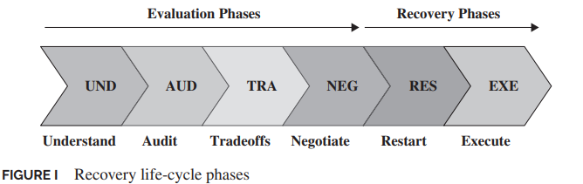

Understand: - understanding the project, reviewing the business case, the expected benefits of the project, the assumptions, and objectives of the project. Client engagements to see where they are at, their needs and ensure that all the objectives are still relevant to their requirements while building their trust.
Audit: - audit the project to ensure that it is still of value and aligns with the client strategy. All stakeholders and the servicing company are still committed to the successful execution of the project.
Trade-offs - list and determine which trade-offs can be made to successfully implement the project on time and in the requirements of the client.
Negotiate - present the reworked plan and determine which trade-offs can be made and which will not be accepted. Align the reviewed plan and solidify and agree the final plan going forward.
Restart - determine which restart option to use, full anaesthetic (complete stop, rework and start), partial anaesthetic (stop noncore work until the scope is stabilised) or Scope Modification (keep work going and modify as required). This will be project dependent and the outcome of the negotiation phase is key in the determination.
Execute - Restart the project work and ensure that historic mistakes are not repeated.
13. Suppose that during the audit phase, Jerry discovered that one of the team
members, who was a close friend of his, was the cause of most of the issues. How
should Jerry handle the situation?
To manage the situation, Jerry would have to determine why? Project fit or personality fit could influence the person’s behaviour. However, failing all corrective approaches, the team member would need to be replaced.
14. What should Jerry do during the negotiation phase if Prylon corporation comes up
with its own recovery plan and the plan is unacceptable to Mannix?
Manage shareholder expectations. Mannix was employed for a reason, Prylon had historically tried to amalgamate the multiple modules and were not successful.
Review the Prylon recovery plan and determine if any items are of value and provide insights into the positive or negative assessment of applications.

